Training Programmes for Managers in the Sphere of Culture Serving Mobility
Julia Bardoun
Director of TRANSIT, Kaliningrad regional non-governmental agency for the Support of Cultural Initiatives
Deputy Director for Organizational Issues of the Kaliningrad Branch of the State Centre of Modern Art
Kaliningrad Region is the westernmost region and one of the youngest regions of the Russian Federation. It is separated from mainland Russia by the territories of several countries. The region is surrounded by EU member states, and geographically is further to the west than some regions of the European Union. This position not only creates certain difficulties for residents of the region connected with the necessity of constant border crossings and the dependence on the general political climate in relations between Russia and EU member states, but also undoubtedly creates favourable conditions for cooperation with European partners. Here, questions of dialogue with European neighbours are of special importance, and the development of practical cooperation and mobility becomes a natural need. Because of this Kaliningrad Region can present itself as a pilot region: an area of experiment where the mechanisms of forming partner relations with colleagues from Europe are being developed and tested.
In the current context, in developing a road map of cultural cooperation between Russia and the EU as a source of ideas concerning the principles and mechanisms of forming such cooperation, the experience of TRANSIT Kaliningrad regional non-governmental agency for the support of cultural initiatives and the European Cultural Foundation may be of interest. The agency has been realizing in Kaliningrad Region since 2006 a long-term programme for development of the potential of cultural establishments of the region. This experience is interesting from the point of view of what principles of interaction with our European partners help to realize projects most effectively, what provides success of the project at a local level and how it is possible to consolidate the local professional community as well as what the prospects of further development are and the application of results of the project in other regions, etc.
In the light of the tasks set by the editors of this collection of articles, we shall try to follow how the programme of vocational training for managers carried out in Kaliningrad Region promoted an increase in the mobility of workers of art culture and development of cultural cooperation in the region.
The programme consisted of two stages: a long-term educational programme for the most active managers of culture in the region and subsequent visits of trained experts to potential partner organizations in Europe.
At the first stage in 2006 the 25 most active heads and employees of organizations of culture in Kaliningrad Region were invited to participate in the project, on a competitive basis. Among them were staff from federal, regional and municipal budgetary institutions, non-governmental, non-commercial organizations and even some specific organizations of departmental subordination. Over two years they met on a regular basis within the framework of discussions devoted to the priorities of developing the sphere of culture in the region and educational seminars concerning cultural management taking place with support from leading Russian and European experts on these issues. The educational programme covered the wide range of issues, from the analysis of existing models of cultural policy and general problems of territories development by the means of culture resources and strategic management, to issues of operative management of culture organizations such as marketing, PR, and audience development, etc. An obligatory part of the programme was the development of strategic plans for the development of organizations by each of the 25 participants.
Educational seminars has become a kind of laboratory, an informal professional club where together with colleagues it is possible to discuss and resolve development problems for organizations and test ideas, etc. Regular meetings and joint development promoted consolidation of the local professional community, coordination of cultural development priorities at a regional level, strengthened the professional identity of managers of culture and institutions, facilitated development by them of the “administrative language” of potential European partners, and formulation of the aims of activity for the long-term and the corresponding expectations from cooperation. Participants could study various approaches to management in the field of culture as well as make a realistic assessment of the situation in the sphere of culture in the region, realize the advantages and shortcomings of their institutions, formulate the strategic goals of development and feel potential points of growth. Today, all this allows them to make a conscious choice in favour of mobility, to realize precisely their own needs in the field of cooperation as well as the expectations of potential partners, and to organize effectively communication and form inter-regional and international cultural cooperation (Fig.1).
Activity
Results
Mobility promotion?

• Regular discussions
• Long-term education programme
• Help in working out strategic plans
for the development of organisations

• Consolidation of the local professional community
• Coordination of priorities of cultural development at the regional level.
• Formulation of strategic aims of the activity of every organization, their advantages and requirements
• Strengthening the professional identity of culture managers and organizations.
• Mastering contemporary language of management

• Active position of participants, recognition of their role in the socio-economic development, “Feeling for the mission”
• Clear formulation of requirements for European partners and deliberate choice in favour of mobility and cooperation
• Readiness of participants for practical cooperation with potential European partners (understanding their management realities, being informed about potential resources for support of cooperation, ability to use them)
Fig. 1. Contribution of the educational programme for culture managers of Kaliningrad Region to the development of mobility
At the second stage of the programme the organizers tried to help the most active Kaliningrad organizations, the heads of which were trained at the previous stage, to come into contact with leading culture organizations of the Baltic Sea region. For this purpose, the Kaliningrad participants made tours to Europe. So, in 2008 within the framework of three trips, the group of 25 visited more than 200 potential partner organizations in 13 European cities, including Berlin, Warsaw, Vilnius, Hamburg, Gdansk, Kiel, Klaipeda, Copenhagen, Luebeck, Riga, Stockholm, Tallinn and Helsinki. Upon arrival to these cities the group was split into four teams, and everyone became acquainted with local organizations according to their own programme in conformity with their sphere of interest (for example, historical museums, maritime museums, centres of the modern art, art galleries and decorative art museums). This gave the participants the opportunity to familiarize themselves on site with the specifics of the activity of each individual organization, the conditions in which this organization works, the priorities of its activity and potential interests with regard to Kaliningrad organizations (Fig. 2).Then in June 2009, within the framework of the project more than 70 representatives of organizations of art and culture from Germany, Latvia, Lithuania, Poland, Finland, Sweden and Estonia came to Kaliningrad. Thanks to their previous visits to Europe, the project participants (and it had been proposed that they generate the list of European visitors) invited visitors to Kaliningrad not at random, but consciously, i.e. understanding with whom it is most expedient to develop cooperation. Over their three-day stay in the region our guests visited almost every Kaliningrad museum, and also the Brakhert museum (Otradnoe), the Baltic Fleet Museum (Baltiysk) and Insterburg castle (Chernyakhovsk). These were not simply excursions, but working meetings aimed at revealing general interests. At the end of the visit, many shared their ideas for cooperation and joint creative plans for the future.
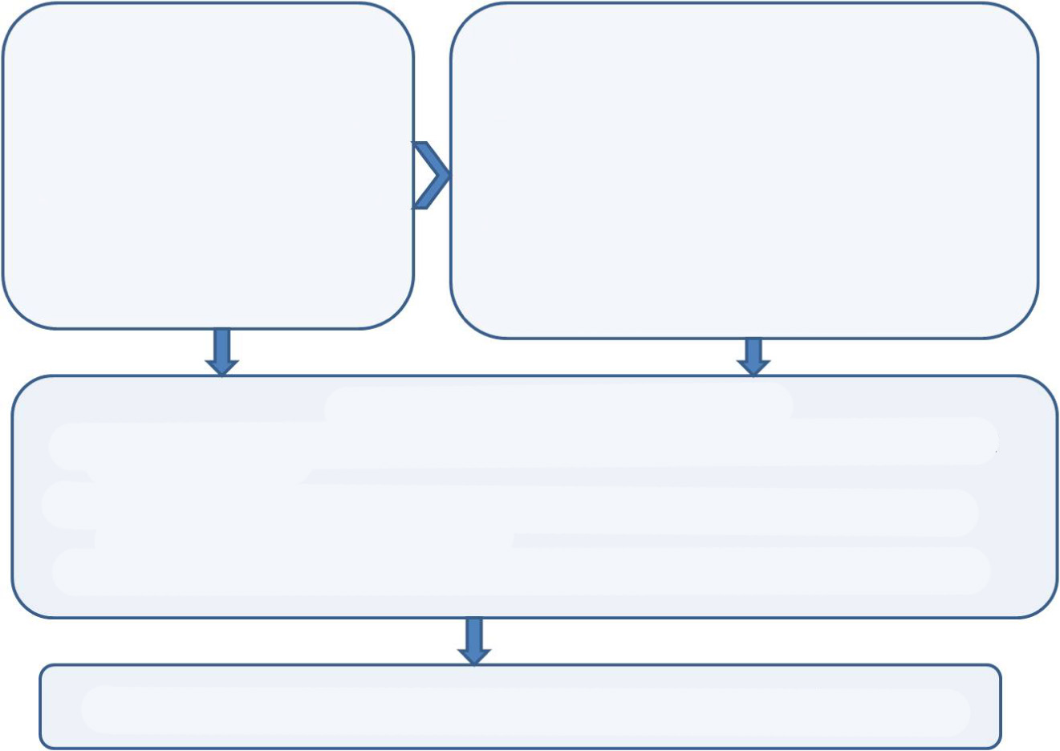
Step 1.
Development of professional skills for 25 managers of culture in Kaliningrad Region
Interim Results
• Participants clearly formulate requirements regarding European partners
• Participants understand the possibilities, requirements and expectations of potential partners Participants are ready for cooperation

• Participants are ready for cooperation from the practical point of view
Step 2.
Mutual Acquaintance of Partners
3 “expeditions” by Kaliningrad managers to 8 European countries (13 cities) visiting over 200 organisations
+ reciprocal visit of 70 potential partners from 8 European countries (12 cities) in Kaliningrad Region
Specific joint initiatives, events...
Fig. 2. Contribution of the programme in building up the potential of culture establishments in Kaliningrad Region to increasing mobility and development of cooperation between organizations of Kaliningrad Region and their European partners
Today it is already possible to see how the last mutual visits have brought about new projects and initiatives. It is enough to trace the example of just one organization, for example, the Kaliningrad branch of the State Centre of Modern Art.
So, after the visit to the State Centre of Modern Art by potential partners in Denmark, the Centre’s employees were invited to Copenhagen again for participation in the work of a laboratory entitled “A thinking metropolis IV: creative processes in the municipal space”, which took place in June 2008 at the Copenhagen International Theatre. Having presented their professional working experience with the identity of the city at the forum, participants from Kaliningrad got acquainted with many professionals working in the sphere of architecture, town-planning, visual arts, etc. Some acquaintances already grew into working relationships and real projects. For example, as a result of acquaintance with a participant of the laboratory, Sharam Entekkhabi, a perfumier and artist of Iranian origin living and working in Berlin, the “72 Maidens” art performance project took place in 2009 in Kaliningrad with his participation. And the resulting art material was subsequently presented in Moscow in the Tsaritsyno State Memorial Estate within the framework of the “Topography of happiness: a Russian wedding” exhibition (July, 2009).
In many respects thanks to the visit to the Northern Cultural Foundation and detailed acquaintance with programmes and priorities of the foundation, the State Centre of Modern Art submitted an application to carry out the “Kaliningrad Sound Art Camp” art project. The application was successful and with the support of this foundation, and also the permanent partner of the State Centre of Modern Art, the Ford Foundation, for a week in the summer of 2009 14 artists from Latvia, Lithuania, Poland, Norway, Denmark, Iceland, Sweden and Kaliningrad Region, gathered in Kaliningrad Region working in quite different contexts but united by their general interest in sound as a means of self-expression. It was week of constant dialogue, presentations, master-classes, discussions and joint experiments, the results of which were presented to the visitors in the form of installations, objects and performances on 26 July 2009 in Insterburg castle (Chernyakhovsk, Kaliningrad Region).
Through the Berlin Uqbar gallery (acquaintance with the curators also took place within the framework of the project) cooperation with German artist Romana Schmalisch was launched. In January 2009, within the framework of the State Centre of Modern Art education programme, the Kaliningrad audience was presented with her Mobile Cinema art project, and in the same year again she returned to Kaliningrad to shoot a video about the legend of Soviet oceanography, the Vityaz vessel, one of the main exhibits of the World Ocean Museum. Now, on the basis of materials collected during her visits to Kaliningrad, Romana Schmalisch is preparing another work devoted to the destiny of rural houses of culture.
Three more projects initiated as a result of the visit from potential European partners (“Conversion” together with the centre of modern art Farfabriken (Stockholm, Sweden); “Kaliningrad and its Inhabitants” together with artist Gudrun Wasserman (Germany); “The Sculpture and Palimpsest” together with the Estonian Academy of Arts) are at the conceptualisation and discussions stage. Moreover, in 2009, thanks to the contacts acquired within the framework of the project, 5 curators and artists from Belgium, Poland, Germany and Lithuania visited the State Centre of Modern Art to present their work and discuss prospects for cooperation (this is in addition to those who received such an opportunity within the framework of the official programme of visits).
By example of just one organization it is possible to see how thanks to the processes described above, contacts and cooperation become more active and the mobility of professionals and art products increases. Time will show how long-standing and fruitful the developing cooperation will be. However, it is already possible to assume that the readiness of the local professional community for cooperation (i.e. precise understanding of the purposes of activity and expectations of partners, knowledge of administrative culture of potential partners, their situations and expectations) is a keystone to success; and accordingly, programmes for preparation of managers of culture can play a significant role in the increase of mobility of workers in art and culture.

Details on the activity of TRANSIT can be found at www.tranzit-kaliningrad.ru
Details on the activity of the European Cultural Foundation can be found at www.eurocult.org
There are in fact two projects: “Development of professional skills in the sphere of innovative cultural management with the aim of intensifying cultural cooperation between Kaliningrad Region and countries of the Baltic Sea region” (2008-2009) and “Innovative strategies of local development: increasing the potential of cultural institutions of Kaliningrad Region” (2006-2007), realized by TRANSIT Kaliningrad regional non-governmental agency for the support of cultural initiatives and the European Cultural Foundation together with the Ministry of Culture of Kaliningrad Region, and Association of Managers of Culture with the support of the EU (IBPP-Culture programme) and the Nordic Council of Ministers.

