Old Friends, New Forms: the Royal Shakespeare Company and Its Russian Theatre Collaborations
Deborah Shaw
Associate Director, Royal Shakespeare Company (United Kingdom)
For the present we have heard about a range of exciting artistic, new media and heritage projects funded through the pilot period of the Russian/EU cross-cultural collaboration initiative.
As we look at refining the system for supporting further cultural cooperation, I want to take a moment to step outside of that framework altogether and share with you the particular experience of the Royal Shakespeare Company in its dialogue with Russian theatre. It is a reminder that cross-cultural collaborations do not happen solely in the context of policy initiatives. In fact, as Mr. Shvydkoy intimated this morning, it’s more often the other way round. Political understanding and initiatives follow in the wake of artists, who recognize no national boundaries, just a shared humanity to explore.

The RSC’s theatres in Stratford-upon-Avon
The RSC has been engaged in cross-cultural exchange with Russian theatre for more than 60 years – in fact, it predates the company’s very existence. The inaugural season in the Shakespeare Memorial Theatre in Stratford-upon-Avon in 1932 included a production by the Russian director, Theodore Komissarjervsky, former Director of the Bolshoi, who worked in Stratford over the next seven seasons, bringing what one critic called ‘an avant-garde kick to the Festival’.
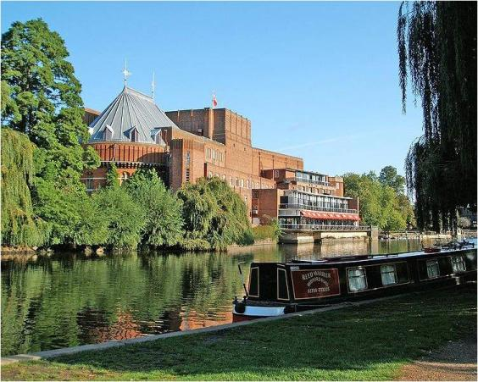
He had worked with Meyerhold in Petrograd early in his career and brought to Stratford the revolutionary non-naturalistic approach of the ‘new Soviet theatre’ movement.
His 1933 Stratford Macbeth caused a stir with its abstract aluminum set, spare lighting and Lady Macbeth’s crown made of saucepan lids.
The Russian approach to ensemble theatre-making was a major influence on the founders of the RSC in the 1960s, with its emphasis on training, working together for a sustained period of time and the whole being greater than the sum of its parts. It could be said that Russian theatre practice is in the DNA of the company.
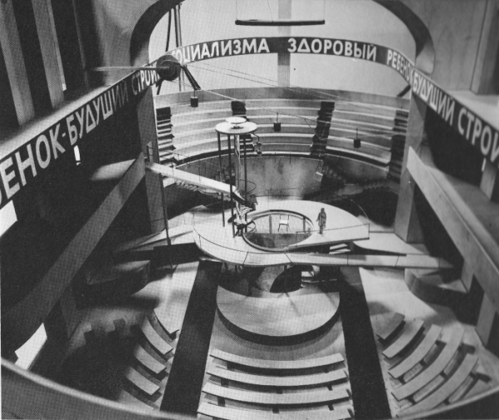
It’s something we return to again and again as we explore how to make Shakespeare for contemporary audiences and it has been re-affirmed in the 3-year contracts for actors brought in by current artistic director, Michael Boyd (who studied in Moscow as a young director). The influence is even playing out in the consideration of the architecture of our theatre spaces.
Meyerhold’s Theatre of the Future (courtesy of V&A)

Meyerhold’s Theatre of the Future is not too distant a relation to the auditorium we are creating in Stratford right now, as we re-conceive our main theatre space to create a stage, which can embrace both the epic and the intimate and provide an intense, actor-focused, communal experience for our audiences.

The RSC’s Courtyard Theatre – a prototype for the reconfigured Royal Shakespeare Theatre that reopens in 2011
In 2005, we began our latest collaboration with Russian artists – an exploration of the interconnection between Russian and British theatre which we call ‘Revolutions’.
It started with a trip of Dominic Cooke, our Associate Director and the RSC Literary team to Moscow, to run workshops with a new generation of playwrights, using Shakespeare’s dramaturgy to inspire them to write big, ambitious plays embracing the public and the private sphere; portraying both the rulers and the ruled.
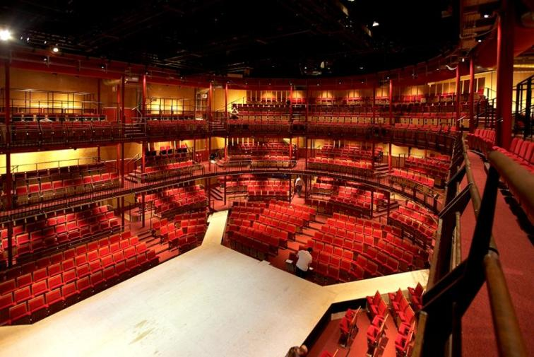
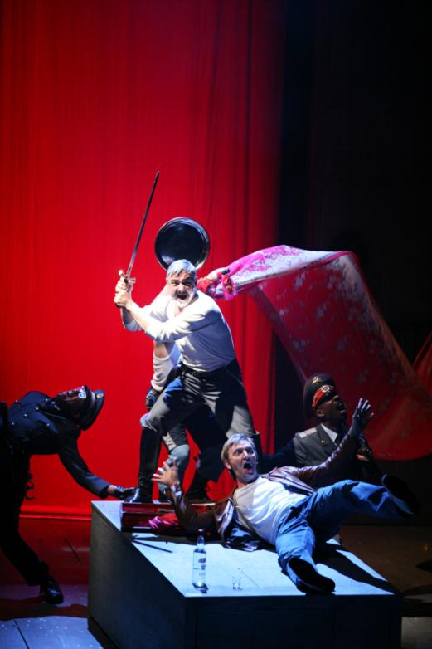
It prepared the ground for a number of commissions, which were developed over the next few years. This resulted in half a dozen play-readings and two premiere productions in the RSC’s 1,000-seater Courtyard Theatre as part of our Stratford season in 2009 – Natal'ia Vorozhbit's The Grain Store and the Durnenkov Brothers’ The Drunks.
A series of public debates and events surrounded the performances, generously supported in part by Chekhov International Festival, the British Council Moscow and the Ministry of Culture of the Russian Federation, bringing Russian and British artists from theatre, visual arts and contemporary pop culture together with academics, broadcasters and cultural commentators for wide-ranging conversations around culture, history and politics. We had a Russian photographic exhibition curated by Liza Faktor, workshops for school students on Biomechanics and Stanislavski and a series of contemporary play readings.
The Drunks (photo Ellie Kurtz)
In Late Night Young Russia, the theatre hosted an explosive performance of Ivan Vyrypaev’s Oxygen in a unique Russian/British collaboration between RSC actors, Moscow’s DJ Hobot and Top 9, the world champion B-boy crew from St. Petersburg.
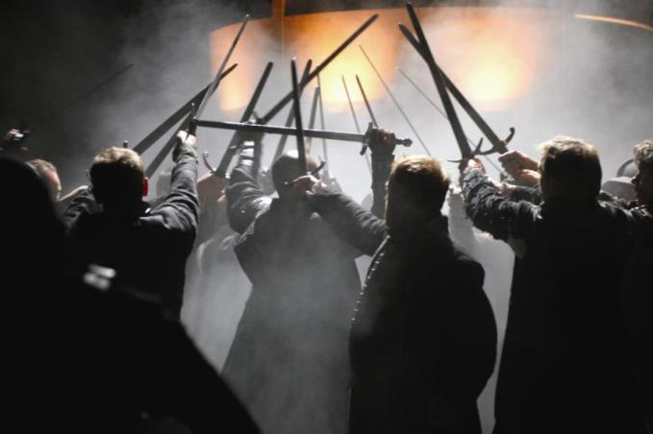
Over several weeks, thousands of British theatregoers were able to engage with a wide range of Russian work with a deep level of engagement. Russian and British actors, writers and directors came together in rehearsal rooms to create work together. And in the wider cultural sphere, Revolutions was the subject of a TV programme by a major UK network, podcasts, radio discussions on the BBC, blogs in Russia and miles of newspaper print.
Photo: Ellie Kurtz
The conversation will continue when we take the plays to London later this year and as we discuss bringing the RSC to Moscow in 2011 and a return Russian visit to the RSC-produced World Shakespeare Festival, which will be part of the official culture celebrations of the London Olympics in 2012.

New technologies have also revolutionized our creative conversations. To make Late Night Young Russia, a dialogue with our Russian collaborators was instigated via the internet. Over a period of 6 months, emails were exchanged with Yuri the DJ and Anton the B-boy dancer; music files downloaded and YouTube clips shared, in a rolling virtual conversation where we discussed our influences and obsessions. ‘Look at this’ I would say ‘It’s a clip from Alex Rigola’s production of Brecht’s St. Joan of the Stockyards at Theatre Lliure in Barcelona – I love the pared-down aesthetic and the sense that you’re at a gig, but there’s a narrative’. ‘Here’s a clip of us’ Top 9 would respond ‘We’re trying to move into performance – here’s our first attempt’. As we found a mutual understanding, we began to map out what we wanted to create on stage with music, dance and Vyrypaev’s seminal text (called ‘a manifesto for the new generation’ by a Russian critic in 2003). We had just 48 hours together in Stratford to put the performance together. There was an initial jolt of panic as this unlikely mix of strangers met, physically, for the first time – seven young street dancers from St. Petersburg, a Russian VDJ more used to playing vast stadia with Russian hip-hop band, Kasta, two nervous but excited RSC actors and a director wondering ‘How can this possibly work?’ But within an hour, in a hot RSC rehearsal room, the differences in nationality, culture, age, experience, social background and language melted away as we rediscovered our shared creative endeavour and virtual friendships became real. The production has now been invited to the London International Festival of Theatre in 2010.
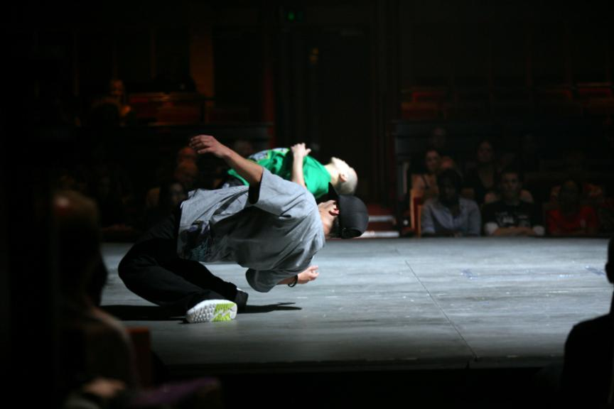
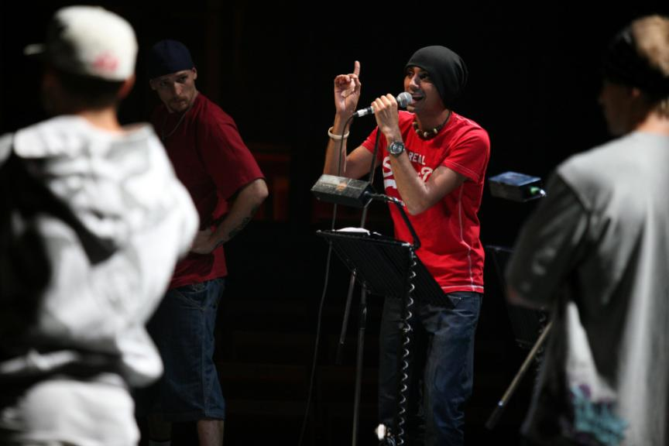

Late Night Young Russia (Photos: Ellie Kurtz)

Late Night Young Russia is an example of how traditional hierarchies and routes into the arts are being circumvented through new technology. Mass communication and social networking has opened up a new era of entitlement and brings the arts into a more democratic, participatory sphere than ever before. It makes us question the role of major cultural institutions – no longer as bastions of high art, created by a privileged few, but as enablers, partners and nurturers of emerging talent, in a sustained two-way dialogue with our audiences, able to create new communities and connections in an increasingly ‘granular’ society. (The RSC is currently exploring how it can bring the principles of ensemble theatre into its relationships with its local, national and international audiences). It is a rapidly changing landscape we need to consider as we move along the road map of Russian/EU cultural cooperation.
In conclusion I want to add a couple of practical suggestions to the conversation today. Firstly, it is necessary to reiterate the concerns of others on increased visa restrictions. We need to lobby governments and border agencies and make a clear argument for a special case for artists.

Secondly, I urge that any funding framework should not be too prescriptive. Let artists choose the number of collaborators and the mix of nationalities – lose the quotas. Have a rolling application process, so arts organisations don’t have to work to bureaucratic deadlines but can apply for funding to their own, often complex planning timetables.
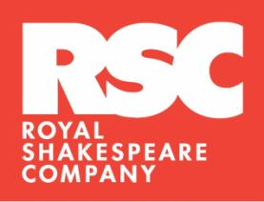

And finally – bring artists into the process – invite them to invaluable discussions like this one; involve them in peer assessment and in project selection. That way we will be able to recognize and reward artistic excellence across all scales, from ideas through to final productions and projects.

