Restoring Cultural Heritage and Empowering Young Citizens through Voluntary Work: a French Contribution To Russian Heritage Preservation with REMPART
Marie Georges Pagel Brousse
Vice-President, Union REMPART
Fabrice Duffaud
Head of International Relations Department, Union REMPART
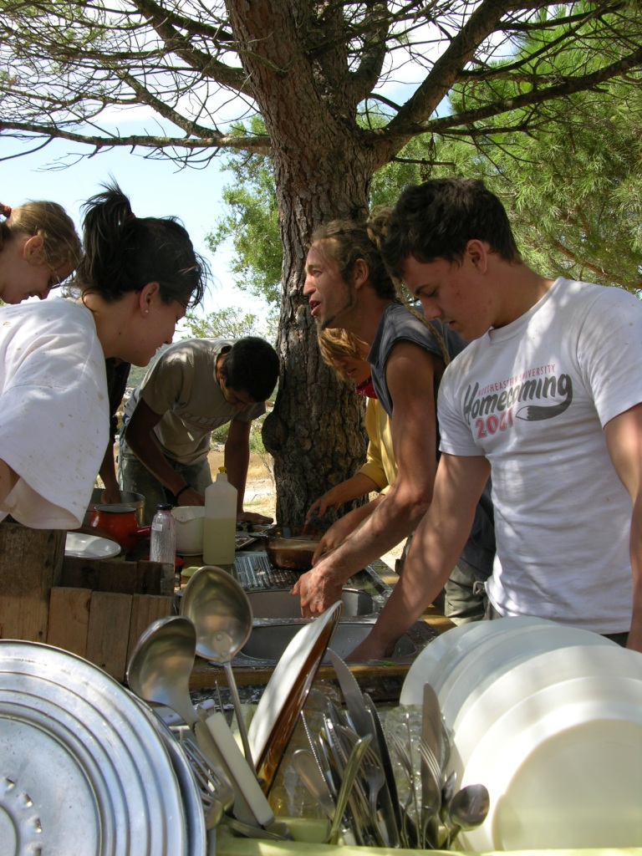
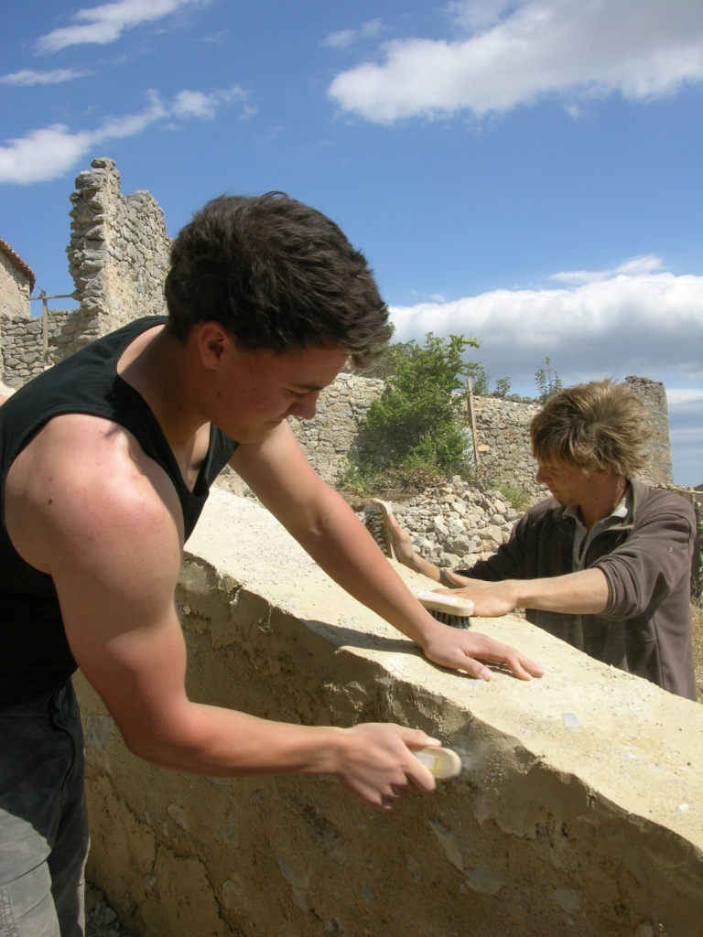
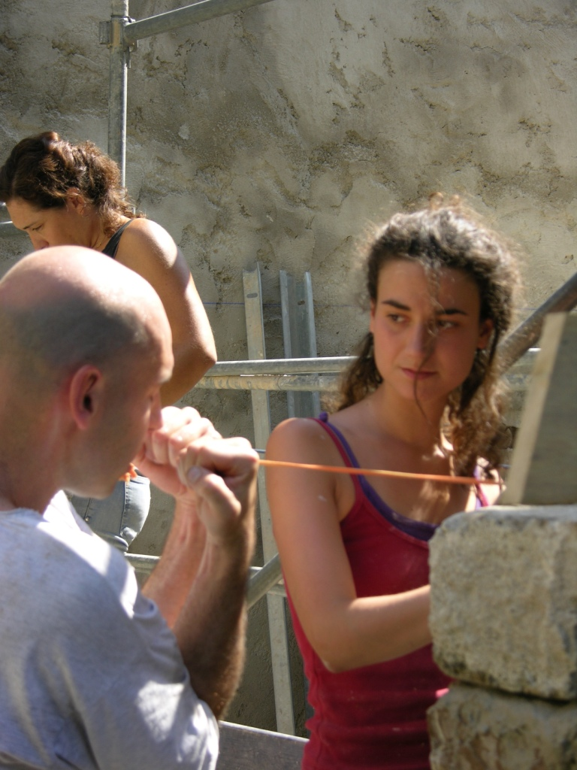

About REMART
REMPART is a French NGO dealing with heritage preservation and voluntary work for 40 years. Gathering 170 French associations which organize voluntary work camps throughout France in the field of the heritage conservation, every year REMPART welcomes volunteers coming from France and from all around the world, skilled or not. Taking part in a voluntary work camp, volunteers get personally involved in the heritage preservation, get familiar with traditional restoration techniques, and live a unique experience. As we believe that heritage is common to all human beings, we wish to share our experience with partners abroad to promote the involvement of the civil society for heritage preservation. This idea has been at the core of our cooperation with the NFRRCE these last two years. We do hope that the project we conducted together in Voronino during summer 2008 and 2009 proves that the civil society, and especially the young people, can and must be active for the heritage preservation in Russia. Working together has been incredibly empowering for both side, and a deep source of intercultural dialogue between Europeans and Russians volunteers.

REMPART: Civil Society for Heritage Preservation
REMPART, established in 1966, is a union of 170 French non-profit associations run mostly by volunteers who are not professionals for heritage preservation. Our aim is to raise awareness, especially among young people, about cultural heritage and its preservation through various actions. We believe that the restoration in itself is important but we think that it is useless if the restored building is not used in everyday life. That’s why every member association has adopted a long-term project for a building it cares about. This long-term project guarantees the conservation and transmission of the building to future generations. To fulfill our goals and achieve our objective to preserve heritage and educate the people, we have developed several activities.
Our main activity is the voluntary work camp. Most of the work camps take place from July to September and last two weeks. They welcome each year about 3,500 volunteers (25% from them come from abroad). During the work camps, volunteers learn numerous techniques: drawing, excavations, masonry, stone carving, carpentry, coating, etc. Our associations wish to preserve ancient techniques of restoration and use traditional regional materials, but modern techniques are also used when it is not possible to do it in another way. The work camps provide the youth the opportunity to feel responsible of the improvement of the living environment. The work camps allow them also to experience a community life and to meet young people of different social backgrounds or countries. Beyond the work camp, we provide volunteers the opportunity to acquire advanced techniques and pedagogical skills as well. These training programs aim to help the most motivated volunteers to become work camp leaders or board members of local associations.
Since REMPART takes care as much of human beings as of heritage, we have been implementing for more than 20 years trainings for people that are less fortunate. During periods from 3 months to 2 years, we host about 200 persons every year and give them training and work experience by being involved in the preservation work of historical sites. This experience provides them with new skills on the technical and personal levels; they are better prepared for their professional life.
For younger people, we organize educational activities for school children during their free time: more than 22,000 children take part in these activities each year. It develops their awareness regarding their heritage and culture.
We publish also a collection of books, Patrimoine Vivant (26 titles), dedicated to specific kinds of historic buildings (for instance monasteries, rural heritage, gothic architecture, train stations, etc).
As we believe that heritage is common to all human beings, we wish to play a greater role in the conservation of the heritage throughout the world. We want to share our more than 40 years of experience with partners in foreign countries to promote the involvement of the civil society for heritage preservation. In 2005 we wanted to set up cooperation with a Russia organization, and NF RRCE appeared to be the most appropriate one.

The Origins of a Fruitful Cooperation
REMPART and NF RRCE have contacts since 2005, when the representative of the NF RRCE in Paris, visited the REMPART office at the first time to discuss the possibility to organize the international volunteer camp in Voronino. This theme was developed in 2006 in Ireland on a meeting of the European Network of the National Heritage Organizations (ENNHO which is now better known as INTO Europe). We have been in touch on a very regular basis to develop a common project for the implementation of the first European-type voluntary workcamps in Russia for the heritage preservation. Due to this idea a delegation of 2 representatives from NF RRCE along with 5 young volunteers were hosted by REMPART in August 2007 to experience a voluntary workcamp in France (thanks to the support of the French Ministry of Culture).
In January 2007 we, REMPART and NF RRCE, decided to set up a project to implement the first European-type voluntary work camp for heritage in Russia. REMPART brought its experience of similar cooperation projects with foreign partners (with Israel, Chili, Hungary) and its experience of EU granted projects (with Palestine). NF RRCE supervised the project, and REMPART contributed to write the proposal and to define the activities, especially the activities where French people are involved.
In that context, REMPART was an actor of the training for project managers and work camp leaders by hosting in France the Russian professionals and future leaders, and by bringing French experienced project managers and work camp leaders to Russia to share their experience with NF RRCE team. REMPART was also involved in the organization of the voluntary work camps organized by NF RRCE by bringing experienced French work camp leaders to assist NF RRCE work camp leaders. In addition, REMPART shared its educational documents and methodology with NF RRCE to help creating a guidebook for the organization of voluntary work camps in Russia. REMPART finally was very active for the promotion of this cooperation in France and in Europe through its partners and networks. Indeed, the Voronino’s project has given birth to an information campaign in France and Europe. Several public events have been organized to introduce this project especially in Paris to the International Cultural Heritage Show (November 2008). The 8th of November 2008, REMPART organized a conference about volunteerism. Two REMPART leaders and two volunteers were invited to talk and share their living experience of the project. The history of cooperation between REMPART and the NFRRCE was valued as well as the European programme of support to cultural initiatives in Russia.

REMPART and the Work Camp in Voronino
It was the first time REMPART cooperates with a Russian organization, and we were very enthusiastic about this project because it was the first Russian-European voluntary work camp for heritage preservation in Russia. We succeeded to convince the European Union about the interests of such a project: to raise the awareness about heritage preservation, to protect cultural heritage, to reuse a historic building for public use, to provide young people with the opportunity to get involved in a useful project, to encourage intercultural dialogue between Europeans union citizens and Russians, etc, etc. But then we had to finalize everything to make the dream come true. In France we had to find the team of leaders and volunteers to take part in this project. We selected three leaders who had the experience in leading voluntary work camps in France, and twenty five volunteers. They were very motivated for the project because almost none of them had been to Russia before, so they were excited to discover the Russian heritage and to meet Russian volunteers and Russian people in general. The two years of project went very well after a total of three months of work on site, 2 seminaries in France and two evaluation meetings in Moscow. Here are some comments about this successful experience, from a French point of view.

The Seminars
These seminars and trainings were essential to the project, because there were the moments when the Russian and French professionals meet to exchange know-how and best practices about the organization of voluntary work camps for heritage preservation. These meetings were the key for the capacity building of the NF RRCE to organize voluntary work camps for heritage preservation in Russia.
The Russian professional have learnt a lot from the French leaders and the REMPART experiences, while the French leaders have learnt a lot from the Russian heritage, know-how and new visions about the organization of voluntary activities for the heritage preservation.
In that way, one can consider that trainings and seminars were more an exchange of knowledge between REMPART leaders and NFRRCE team. We did not want to organize a real “training course” (the REMPART leaders teaching the Russian leaders how to organize a work camp), because we believe that NFRRCE had to find its own way to organize a work camp, taking into account the REMPART experience, but adapting it to the Russian context.

The Volunteers
The work camp was first a human experience, it gathered a very mixed group (a total of about 75 each year): boys and girls, minors and adults, Russians and Europeans, different social and cultural backgrounds, different languages. The work camp was very enriching for all of them because it was an opportunity to meet people from very different backgrounds that could not meet without such a project.
It was a new experience for most of the volunteers and they had the opportunity to learn to work with their hands. They learned also to be responsible for achieving a work of good quality, they learned to live with a group, to be responsible for daily tasks (cooking, cleaning, and washing up). Such experiences make the youngest volunteers more mature.
The work camp allowed them to better know each other especially by sharing the daily life. Such a project created lots of new connections and friendships between the people from different backgrounds.

The Work
A work camp must have educational objectives so it is important to make the volunteers to do an interesting work. In Voronino they had the opportunity to learn the history and daily life of a typical Russian aristocratic estate. Volunteers were not professionals so they did not work as fast as professionals would do, but they did their best to work properly with a high quality, with the help of the leaders.
NFRRCE provided tools needed on the work camp so that the volunteers could work in good conditions. The volunteers learned how to use the tools and the materials, and were responsible for keeping them clean after the work.
It is essential to explain the security rules to the volunteers from the beginning of the work camp, because it was not obvious for volunteers to have the right behavior on a work area. The leaders explained what to do and not to do on the work camp, how to deal with the tools…

The Leaders
There were two Russians and two French leaders on each session to supervise the work camp. It was not always easy for them to agree on the way to lead the work camp and to take the same decisions. But it was very enriching for them to compare the different visions and attitudes in a multicultural team. This shows that it is important that a leading team must be composed by persons with complementary skills.
It is essential to have one person who is always on the work camp and responsible for supervising all the leaders and for taking decisions. The leaders must follow these decisions and supervise the work of the volunteers, especially at the beginning so that the volunteers do the work properly.
Some volunteers were very motivated and devoted to the project: they could become leaders in the future, but they must be trained to learn how to lead such a project. If they improve their experience and continue their involvement, they could organize similar projects in the future in Russia.

The Group Life
The volunteers were hosted in tents (boys and girls separated).
The volunteers were supposed to help the cook prepare meals. Some volunteers took the initiative to cook special recipes.
Several visits were organized during the free time: it is important to give volunteers the opportunity to better know the local culture and heritage. It was especially important for foreign volunteers to see with their own eyes how a country does like Russia live its daily routine, and to compare this with what they had in mind before coming. A work camp is also a window open on its environment.

The Community Outreach
This project benefited the whole community and not only the participants: it is important to make the community (the local inhabitants) understand that the work camp brings activities to the whole village; the exchanges between the volunteers and the inhabitants, the media coverage of the work camp, and the future public reuse of the estate after the work camp
It is essential that the local authorities help as much as possible these kinds of projects, because it benefits the whole community. A permanent support from the municipality is required to make such projects successful.
Perspectives of Development
As everywhere, the cultural and natural heritage in Russia deserves to be protected and preserved, but it is only possible if the people are aware of it. In involving young people in a volunteer work, REMPART helped to the increase of the awareness of the Russian heritage and even a worldwide one because we try to adapt best practices linked to our various experiences abroad. A mutual enrichment allows us to see our own weaknesses. For example, this action with the Russian people brought us to a better understanding of the Russian volunteers coming to France, it means about one hundred a year and it means the first nationality among the others. Voronino is like a drop in an ocean but Voronino is a seed too, showing what could be done here in Russia. It results of it a real necessity to keep on that kind of project following an aim of restoration while helping to social useful meetings. REMPART is 43 years old, so two years here is short but it is a very beginning. We are on hand and ready to help to the development of similar enterprises in Russia and of course we wish to go on with NFRCCE. We would like to warmly thank the French Ministry of foreign and European affairs and the French ministry of Culture and Communication for giving us, as they did for long years now, their support and confidence to implement such positive projects for mutual understanding between France and the Federation of Russia. We do hope this work camp proved that the civil society, and especially young people, can and must be active in heritage preservation. And we hope this work camp opens the way for future voluntary work camps throughout Russia.

Contact Information
Union REMPART
1 rue des Guillemites - FRANCE - 75004 Paris
Tel: +33.1.42.71.62.72 / Fax: +33.1.42.71.73.00
www.rempart.com
duffaud@rempart.com

