Cooperation in the field of Exchange of Digital Collections and Cultural Content
Alfredo Ronchi
Professor, Politecnico di Milano
Secretary, MEDICI Framework of Cooperation (Italy)

Preamble
I will briefly introduce the EC MEDICI Framework of Cooperation, originated under umbrella of the European Commission and grown up at international level after the start up period. Main projects care of MEDICI: information sharing, research projects, initiative in the field of education. A brief overview on recent MEDICI’s initiatives: “On culture in a world wide information society”, “Intangible heritage: a proper digital format”, “EU directives & cultural heritage”, “EU legislation & cultural heritage”, Planned conservation & “Monuments Integrated Management System”, “Long term preservation of digital content”, Monument’s ID Card & Visual documentation of monuments, cultural tourism 2.0 etc. MEDICI and the World Summit Award (section eCulture and Heritage).

Cooperation in the field of Exchange of Digital Collections and Cultural Content
Starting from the main activities carried out by museums/archives: preservation, research, education/ dissemination we will outline the potential role of digital “objects”. Which are the role and the opportunities related to the use of digital technology in “memory institutions”? What do we expect from high end digital collections and from on line digital collections? How do we consider user generated content in this domain?
How can we approach the global inventory and filing of digital originals, multilingual thesauri, specific ontology, international standards (text, visual, audio, audio/visual, etc)? Do virtual collections really provide added value to end-users? Are museums, content providers and users ready and willing to use new technologies to explore cultural heritage? Do ICT tools really help content holders and/or end-users? Shall we now try to provide some answers? Have we mastered the general framework? Is the necessary technological framework already in place? Are the requested competences and skills already available in this domain?

Background
In the last thirty years many relevant players in both the museum and ICT communities invested time and resources into creating pilot projects and applications ranging from 3-D reconstructions and digital collections, to virtual museums. We are now in a position to consider whether such investments are effectively useful and really do increase and promote knowledge of the arts, sciences and history, and whether they satisfy users’ requirements. Do virtual museums and digital collections really provide added value to end-users? Are museums, content providers and users ready and willing to apply new technologies to cultural heritage? In the twenty-first century, the Information Society era, does the nineteenth century’s encyclopaedic approach to museums still survive? Do ICT tools really help content holders and/or end-users?
Early in the 1990s, as a follow-up to a set of concrete experiences, I wrote some papers and articles entitled “Real Virtuality...”, to emphasise some concrete results and a case study that could aid the generation of new ideas regarding and potential future applications of digital technology in the field of culture.
Today, almost twenty years after interactive virtual reality was first exploited, and more than fifteen years after the “explosion” of the Internet, a wide range of technologies are on the shelf, a number of applications and services are available, so what is missing? What are the opportunities and the threats?
Digital communication is the most recent link in a long chain, which started with nonverbal communication and gestures, evolved into languages, signs and writing, and then developed into printing, broadcasting and other media and formats. Do we use digital communication in the best way? Just how much are we really exploiting the potential offered by digital media? Is multimedia simply the sum of different media, or is it more than this?
Let us “historically” frame this subject with an overview on main events that have characterised the evolution of the Information Communication Technology applications dedicated to cultural and social issues. For the purpose of this paper we will not consider early attempts to develop IT based solutions for culture and cultural heritage such as filing and archiving systems.
Going back, almost two decades, to the early 90’s we may refer both to the US project entitled “Information Superhighways” and to the “Bangemann Report” that, in partial antithesis, presented the “European way” towards the Information Society.
On February 1995, the European Commission organised in Brussels the first event on the Information Society. During the meeting, a list of eleven pilot projects was approved:
- Global Inventory (of projects);
- Global Interoperability;
- Cross Cultural Education and Training;
- Bibliotheca Universalis;
- Multimedia Access to World Cultural Heritage;
- Environment;
- Global emergency;
- Government on-line;
- Global Healthcare;
- Global Marketplace for SME’s;
- Maritime Information Systems.
The aim of those projects was to trace the Information Society guidelines.
On June 1995, a world-wide G7 Summit was held in Halifax, Canada. The G7 Group approved and made its own the abovementioned list of projects. Consequently practical demonstrations followed during the ISAD Conference (Information Society and Developing Countries) held in Midrand, South Africa on May 1996. During this conference, four demo projects were selected, representing the four principal sections identified by the “Multimedia Access to World Cultural Heritage”.
Focusing on European initiatives, during 1996 the complement of the frame so defined was born thanks to the combined initiative.
The reference document was substantially a Declaration of Intent initially signed by 240 museums and institutions. In this context, there was a development of a likely organic approach to the use of multimedia and more generally of the ICT in the field of cultural heritage.
The “Memorandum of Understanding for Multimedia Access to Europe’s Cultural Heritage” or simply the MoU, is properly considered the Act of Incorporation for the “Information Company on European Cultural Heritage”.
The MoU lasted, as stated in the document itself, for two years then the European Commission issued a “call for tender” asking for follow up projects. MoU was mainly a declaration of intents the follow up has to be much more pragmatic. In 1997, the new “agency” called MEDICI Framework of Cooperation was launched.

MEDICI Framework
A partnership was developed between the MEDICI initiative and the Council of Europe in the application of new information technologies in the cultural field.
The goal of MEDICI is to promote the use of advanced technologies for access to, understanding, preservation and economic promotion of cultural heritage. The end-goal of economic promotion means creating conditions for the development of new economic activities able to bring to a new fruition the cultural heritage, and to create new employment opportunities in its relevant sectors.
The official MoU progress report dated April 1996 reported that the third area that can be defined as application and testing, “will be made up of projects that are market-oriented and based on the fruition of cultural heritage. This area will include projects aiming at producing advanced cultural applications by using the present technological resources in key sectors (education, entertainment, cultural tourism, disadvantaged users etc.).”
In this area, an assessment of museums initiatives outlines that the World Wide Web assumed a leading position within the “Multimedia Access to World Cultural Heritage” project.
Following such a trend MEDICI Framework, already involved in Web technology from the early beginning, started a close cooperation with the World Wide Web Conference initiative.
Following the interesting experience carried out on the occasion of WWW7 in Brisbane (April 1997) on the occasion of the 9th World Wide Web Conference held in Amsterdam (May 2000) , a complete set of sessions called “Culture Track” was devoted to draw a comprehensive scenario on emerging technologies and trends on “networked arts”.
With specific reference to virtual museums, WWW9 Culture Track explored how multimedia technology could re-engineer the way visitors presently perceive their visiting a museum or art gallery.
In order to explore the whole scenario additional topics were: benefit associated to ICT applications; real issues of museums & archives; e-society, e-commerce and e-services.
One of the basic ideas in the field of on line exhibits was, at that time, the market model based on images copyright on line commerce. An additional discussion topic was no doubt the “increasing gap” or “digital divide”.
From 1999 to 2009 MEDICI promoted and supported a number of research projects and working groups (“On culture in a world wide information society”(1999-2002), “Intangible heritage: a proper digital format” (2004), “EU directives & cultural heritage” (2003-2006), “EU legislation & cultural heritage” (2008,-), Planned conservation & “Monuments Integrated Management System” (1997-2008), “Long term preservation of digital content” (1999–2008), Monument’s ID Card & Visual documentation of monuments (2009-), Cultural tourism 2.0 etc (2008 -), MEDICI and the World Summit Award (section eCulture and Heritage – 2004, -). In the same period of time a number of conferences and workshops were activated by MEDICI such as: the panels “On culture in a world wide information society” WWW Conferences (2001-2004), the International Conference Cultural Heritage Networks Hypermedia (1996-2006), co-organisation of Infopoverty Conferences 2001-08, the panels “Business opportunities from cultural heritage” (on the occasion of CeBIT 1998-2008 Hannover), the eCulture tracks of Global Forum (1997-2009).

Digital Revolution
In order to adequately take into account the role and the potential of digital collections we need to consider first of all the effects of the so called “digital revolution”. What is the role and what are the effects of the digital revolution? Which opportunities and threats are associated with digital information? In the present context, the term digital information is better than electronic information because it more accurately captures the essential aspects of the topic.
From an ontological point of view, we are dealing with a new class of objects. Copies are clones equal to the “originals”, duplication cost is almost nothing, transmission and dissemination costs are almost zero and no more physical barriers and customs, everything freely flows through the Internet. The concept of ownership of the original becomes meaningless, in the digital world access means ownership, intellectual property and copyright are reshaped.
It is not surprising that digital information and its related technologies have the potential to make a huge impact on culture and society. In addition, to ignite the innovation process one of the most significant changes to occur in the field of information technology over the last few decades has been the implementation of real-time communication and information exchange between computers: networking.
A computer was originally considered to be Leibniz’s“monad”, an ultimate atom without windows and doors; a sealed entity. Intercommunication processes activated external access to these monads, allowing information and data exchange between them and thus multiplying their added value; networks of computers possess expanded functionalities and services. A number of different standalone proprietary networks were gradually merged into the network of networks: the Internet.
The Internet, the de facto implementation of global networking has revolutionised the worlds of computing and communications like nothing before.
The incredibly fast growth of the Internet boosted the revolution and now we must consider Internet as a pillar even in social communication. This means that access to such a relevant infrastructure becomes a key point.
Accessibility issues came to the fore at the end of the 1990s, supported by technological issues related to the potential social role of the Internet. If the Internet has a “social” role, then, in order to avoid any “divide“, it must be accessible by anyone, anywhere, and at any time. If access to cultural content and services has to be considered a social good it must be accessible to everybody, no matter about gender, age, richness, or eventually disabilities.
Internet World Stats (www.internet-worldstats.com) reports that there are close to 1.5 billion Internet users today (July 2009). comScore (www.com-score.com), an Internet research/analysis organisation, reported in January 2009 that the global Internet audience (defined as 15 years of age and older accessing the Internet from home and work computers) has surpassed 1 billion users (note that the comScore report excludes Internet access from cybercafés, mobile phones and PDAs which probably represents the difference in numbers between the two reporting organisations).
Some years ago the report New Information Technologies and the Young identified the extent of provision and access to technologies, the ways in which young people use them, and some of the opportunities and difficulties associated with each form of communication and expression. The report provides a comprehensive picture of young people as users and consumers of new technologies, but especially in terms of their creative activity, such as their use of digital audio and video, website creation, and distributing visual, musical or literary work across the Internet.
These numbers are growing rapidly and will continue to do so. The “next billion”, as some authors call them, and the billions after that will be online much quicker than the first billion; this then makes the Internet an important global public policy issue.
The Internet that is taken for granted by so many needs to continue its evolution around the fundamentals upon which it was founded. These fundamentals relate to the concept of user centricity, where the Internet user and how they use the Internet should be the primary focus of decisions and developments on the Internet. The concept of user centricity characterised, perhaps for the first time in computer technology, the birth and early development of the web technology. From the beginning up to, at least, 1995 the World Wide Web technology was built based on the request of users directly from users.
Another defining feature of the Internet’s success has been the open nature of the technical standards, and the innovation this has allowed. The innovation have been key to a large number of new technologies that have evolved out the Internet, and it is important that this continues so that we keep finding new ways to do some of these old things cheaper, better and faster.

A Digital Domain in an Analogue World
The digital domain is populated both by native digital content and by native analogue converted to digital format content. The last one is the result of digitisation processes.
The native format used to be analogue, but it has recently become possible to find “native” digital content. This means that the “original” content was created or acquired in digital format, so there is no analogue / physical original. This applies for instance to digital video and audio recordings or “digital art” artefacts.
Native digital content should not be confused with the so-called “digital original”. The term “digital original” used to be applied to a “perfect” digital double of the original physical “object” that is suitable for any use; research, display, etc. This means that the physical original of the digital original is available for future digitisation. In contrast, “native” digital objects are basically the only resource available. The quality, comprehensiveness and preservation of native digital objects are bounded by the digital technology utilised.
We all know that digitisation means “segmentation” into slices, such that the digitised data has defined resolution and quality. Once the standard has been defined (in terms of resolution, palette, frequency sampling,), there is no way to accurately recreate the portion of information that is lost. In other terms, when creating native digital objects we must consider the quality, comprehensiveness and long-term preservation of the content, because there is no physical reference object to go back to.
Native digital content is increasing in quantity and variety, mainly in under the umbrella of user generated content (UGC). Digital documents, publications, recordings, drawings, sketches, illustrations, pictures, movies, music and more are being produced.
An incredible amount of data has moved from the original analogue format to the digital one; for example, traditional cameras are now almost exclusively used by high-level professionals or are found in collectors markets.
This upsurge in computer use resulted in a tidal wave of new objects, such as playlists, SMS, podcasting, personal websites, communities, blogs, wikis, and more.
In this scenario, interactive installations and the digital preservation of intangible heritage represent some of the most difficult content to manage.
Most of our heritage was not born in digital format; some of it has a physical appearance, some must be performed or played, and some is even more “intangible”.
Some of this patrimony has already been converted into a digital format, but it must still be harmonised or updated to a new standard from time to time. Since a new standard usually performs better than the old one, we encounter a dilemma if the original artefact is still accessible: should we convert it or start from scratch?
Which is the right choice? There is no “default” answer, but it is often better to start from scratch and acquire digital data instead of reusing or modifying existing information.
Even though native digital content is becoming increasingly popular, and so the demand for digitisation is dropping, there are still many items that need to be digitised even if we only consider cultural heritage: monuments and archaeological sites, codices, statues, paintings, historical records, etc.
Each data stream that is collected as the representation of a virtual environment contributes to contextualising and creating an “experience”, as some tend to say. Experiences appear to be personal assets that should be acquired and preserved.
If the data we are going to use are not in digital form natively, we need to acquire these data and convert them into a digital format.
We know that “to digitise” means to break the analogue continuum into predefined slices, which inevitably results in the loss of some of the original information.
Digitisation is performed in different ways with different equipment for different classes of data: images, sounds, 3-D objects, and others. We might use image scanners, sound and voice recorders, camcorders, 3-D solid scanners, etc., as equipment. But how do we deal with different classes of data: sounds, images, smells, taste, touch... and behaviour.
Analogue and digital data are fundamentally different: whereas analogue information is generally smooth and continuous, digital information consists of discrete chunks; and whereas analogue information bears a direct and non arbitrary relationship to what it represents, digital information is captured using formal codes that have only an arbitrary and indirect relationship to the source.
Thus, while an analogue image, for instance, consists of continuously varying colours and shading, a digital image consists of a set of individual dots or pixels, each recording the colour intensity and other information at a given point.
Due to the digital structure of data, the continuum is broken into slices, a best approximation to the given analogue value, and then coded as a sequence of digits (bits). This ensures that there is no degradation of quality between the original digital dataset and any copy. The bit streams representing the information can be transferred correctly, so the information at the destination is equal to the original. While the bit stream may sometimes be corrupted, in this case the error is highlighted and sometimes automatically corrected for by control bits.
Although the specific kind of information stored varies from medium to medium (sound waves, light intensities, colours), this basic difference remains constant.
“Digitisation”, the conversion from analogue to digital, thus requires that the continuous analogue information be sampled, measured, and then recorded in digital format. There are several basic factors which govern this process and which determine the quality of the resulting digital data (density of the data sampled: the resolution, amount of information recorded at each sampling, file size versus quality). The first of these is the density of the data captured from the analogue original; in effect, how often the original is sampled per unit of time (in the case of video and audio) or area (in the case of images and video). The second factor is the amount of information that is recorded during each sampling. Individual pixels in an image may contain very little information; at their most minimal, each may comprise just one binary digit to express “on” versus “off” or “black” and “white”. The last one, sampling frequency (or resolution) and sample size (frequency response, bit depth) both involve a trade-off between data quality and file size.

Why is Digital Communication Revolutionary?
Well, now we have got a perfect copy of the original artefact, what else? We already know about digital communication and networking enabling instant exchange of information and data. As an extension of this, interactive virtual reality provides a powerful tool for knowledge and complex structured information transfer. Furthermore, the electronic industry is now moving from the Internet era, where connectivity and intelligence was built into certain products, to the ubiquitous network society, where everyday objects possess such capabilities.
After the “I” and “e” eras, we are now entering the “u” (for “ubiquitous”) era. This next phase in technological evolution has been given different names: ubiquitous computing in Japan, pervasive computing in the US, and ambient intelligence in Europe. There are, as usual, slight differences between the approaches taken in these different regions: universal access and computational power or “transparent” computer support and cooperative behaviour from the digital environment. Last but not least, we should consider the opportunities and threats caused by the implementation of the so-called e-society, as well as the increasing gap between those who are online and those who are offline.
Nowadays, there are different models, opportunities for, and types of communication: asynchronous or synchronous; mono- or bidirectional; one-to-one, one-to-many, or many-to-many; location-dependent or location-independent; immersive or non immersive; interactive or non interactive, with log file and without log file; wired or wireless. In order to develop more effective communication, we must create new recipes from these different ingredients.
The Internet era offers many benefits, including easy access to broad audience communication, and forums, blogs and Web 2.0 appeared, which are powerful tools.
Mobile communication enabled a kind of virtual ubiquity. Originally intended to be a minor aspect of mobile communication, the utility and popularity of short message service (SMS) messages were initially hugely underestimated as communication tools. As we have seen, they have enabled a new way to work and are an incredibly powerful aid to interpersonal relationships. Today they are often used as a private channel, as opposed to a public channel. SMS offers typing and paging features plus emoticons and the time dimension. The employment of text and the time delay enable the use of imagination the most powerful tool supporting communication.
The increasing number of wireless devices and always on terminals has catalysed the creation of new applications and services, and will continue to do so. However, up to now there has not been a proper way to use technological tools in order to exploit the real advantages of ICT in communication.

Creativity
“Creativity is one of the highest forms of human energy. It is a defining human trait that enables us to design and to use tools, and it gives us the ability to solve problems. In the modern world, creativity and its outcome, innovation, are credited as the greatest predictors for economic advancement, equal to or surpassing investments. Creativity can be a vehicle for empowerment and fulfilment or, if denied or abused, it can lead to frustration, apathy, alienation, and even violence. The role of creativity has been magnified by the explosive developments in Information and Communication Technologies. ICTs are the most powerful means to produce, preserve and communicate the fruits of human creativity, including information, know-how, knowledge, and works of art.”
The idea of the Knowledge Society is to add value to ideas, creativity and interactions. In the new scenario of an enlarged Europe and neighbours countries there is a need to catalyse a common understanding that encourages the richness resulting from cultural diversity but also censures the unwanted effects that can sometimes arise from such diversity (e.g. clashes between cultures), thus leading to a common vision of the European Society. Young people and their special creativity could play an important role in such a scenario, particularly if supported by digital technologies.
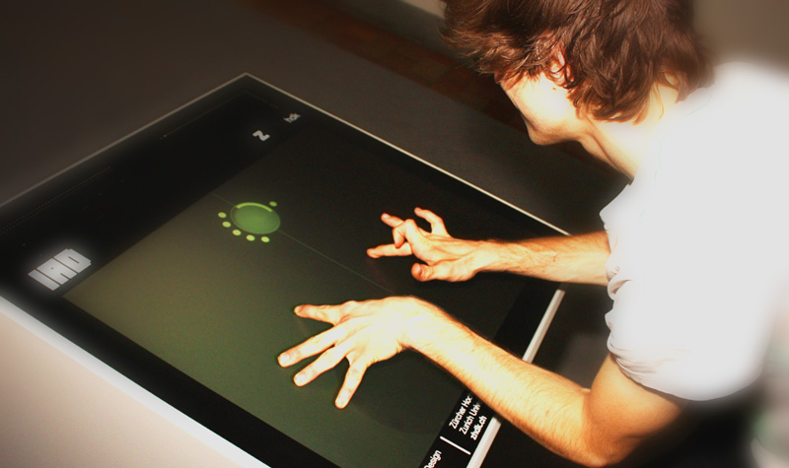
'Akustisch' is a new approach to the use of a multitouch interface for the production, control and manipulation of digital sound.
Digital technology affects our lives in so many areas, including health, security, safety, work and similar fields, and particularly in the fields of cultural interests, creativity, entertainment, communication and relationships.
Digital media have dramatically increased the possibilities available to the artist, by creating new forms of expression and by lowering the costs of producing certain art forms to such a degree that they become within the reach of individuals. As well as specifically digital media, music, still images and video are three significant areas where the costs of producing a finished work have dropped so dramatically that it has encouraged the emergence of new young talents.
Digital technology, and in particular the Internet, has completely overturned traditional ideas about distribution. Any work that can take a digital form can be infinitely reproduced at minimal cost. Young people in particular will be encouraged if they feel that others will see their efforts.
The instant global network provided by the Internet has made the building of special-interest groups unprecedentedly easy. These spaces are where artists talk, and they are excellent places to gauge the state of a scene. In recent times such spaces evolved as shared facilities enabling co-creation of artefacts such as composing and playing music, paintings, movies, software applications and more.
Peer-to-peer technology enables on-the-fly exchange of content, and thus provides unlimited opportunities to share personal content and to activate added-value chains of cooperation.
Creativity must be encouraged, and new interactive cultural expressions must be stimulated. Knowledge is not about the circulation of information. It is about adding value to ideas. A Knowledge Society must provide people with opportunities to think in new ways.
Up to now, ICT has often led to the creation of libraries without books and highways without cars, the technological infrastructure is in place but we can’t do anything useful with it, while ICT companies are still looking for killer applications. However, there are some “enabling” applications and technologies that are still at the development stage but should provide users with useful services.
Software availability is very patchy. The least widely available software includes video/audio authorware, and software for composing music and computer graphics as well as 3-D modelling.
There is a need to channel the creative energies of young people by promoting digital literacy in the field of new ICT-enabled or empowered creativity and expression. There is also a need to create a proactive environment that enhances the overall quality of eContent products. Digital and social divides must be bridged in order to provide access and added value to citizens. Digital technologies and ICT tools provide an incredible opportunity to encourage growth and prosperity. Digital content and services empowered by broadband communications, both wired and wireless, could have a significant impact on society. One of the first steps in this direction is to promote human networking and the exchange of experiences and skills amongst different groups and communities.

Cooperation in the field of Exchange of Digital Collections and Cultural Content
There is a long term tradition in exchanging artefact for the purpose of temporary exhibitions, in this way, in some museums or galleries; we can enjoy a selection of Tiziano’s and Van Gogh’s paintings or an almost complete collection of Vermeer’s. Still a little bit more difficult, but not impossible, to setup a Canova’s sculptures or Michelangelo’s architecture exhibit.
Gipsoteca
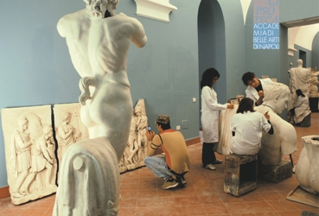

A similar approach cannot satisfy a huge number of “desiderata” because the negotiation of the loans and the risks related to the move and last but not least the costs are a real bottleneck. Of course we can partially solve the problem exchanging copies and clones. Has it happened with the “terracotta army” from Xian or, more recently, with Galileo Galilei’s Telescope. The “clone” approach simplifies the bureaucratic side, anyway some problems are still on the table, physical clones must be available, properly re-created, sometimes in more than one instance, and then we need to ship them to destination.
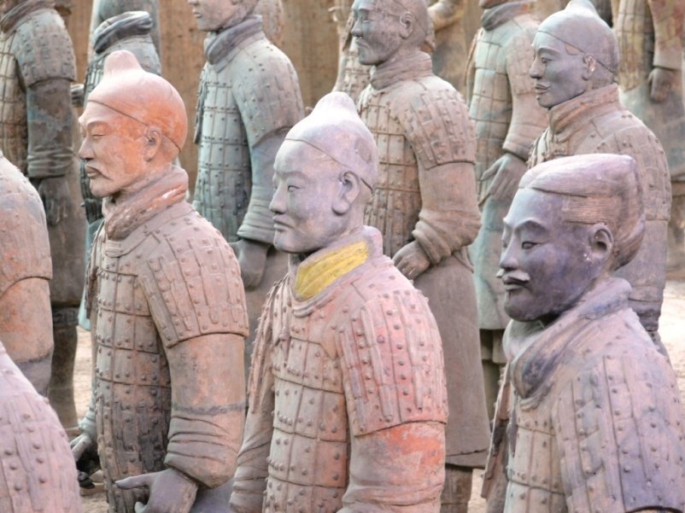

The use of digital technology in order to replicate artefact in “digital originals” improved significantly in the last period of time both due to the technological evolution and the skills acquired by technicians. Digital imaging, solid modelling and rendering, virtual reality did an incredible step forward reaching at the same time high quality and reduced costs. New technologies entered the world of cultural heritage; scanners enabled the creation of excellent clones both in two and three dimensions.
In the last 15 years we have created a number of digital copies addressing different needs.
Apart from the technologist’ interest in testing the copying process and showcasing cutting edge technologies largely supported by the relevance of the “copied” or “represented” object (paintings, Greek temples, well known monuments, etc).

Memory Institutions
Starting from the main activities carried out by museums/archives: preservation, research, education/ dissemination we will outline the potential role of digital “objects”. Which are the role and the opportunities related to the use of digital technology in “memory institutions” ?
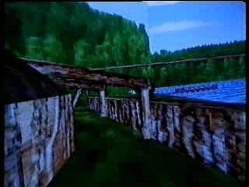
Virtual Viking Village by Ola Odegaard Norway (1993)
What do we expect from high end digital collections and from on line digital collections? How do we consider user generated content in this domain? How can we approach the global inventory and filing of digital originals, multilingual thesauri, specific ontology, international standards (text, visual, audio, audio/visual, etc)? Do virtual collections really provide added value to end-users? Are museums, content providers and users ready and willing to use new technologies to explore cultural heritage? Do ICT tools really help content holders and/or end-users? Shall we now try to provide some answers? Have we mastered the general framework? Is the necessary technological framework already in place? Are the requested competences and skills already available in this domain?

Digital Playground: Conservation, Research, Education
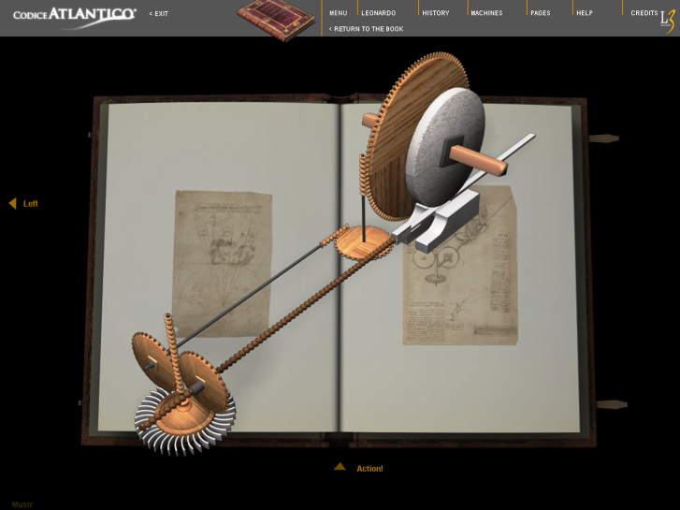
Codex Atlanticus – Leonardo da Vinci by Leonardo 3, Italy
Conservation: how can we take advantage from the use of ICT tools in this field? A short list of main applications is:
- Digital snapshot of the state of “health”. Thanks to high fidelity reproduction of artefacts we can compare through the time the original “image” and the actual one.
- This can be done automatically outlining minor and major differences.
- Digital original (as a quality clone to be “used” instead of the physical original – e.g. codex, manuscripts).
- Digital mapping. A two or three D digital map of the artefact (e.g. historical building), this may enable planned conservation methodology.
- Virtual restoration / refurbishment / etc. (even digital 3D plot). The way to simulate a realistic restoration safe guarding the original artefact. It may be useful for anastilosis in the field of archaeology.
- Digital monitoring. Real time monitoring of the state of health and environmental parameters.
- ... more.
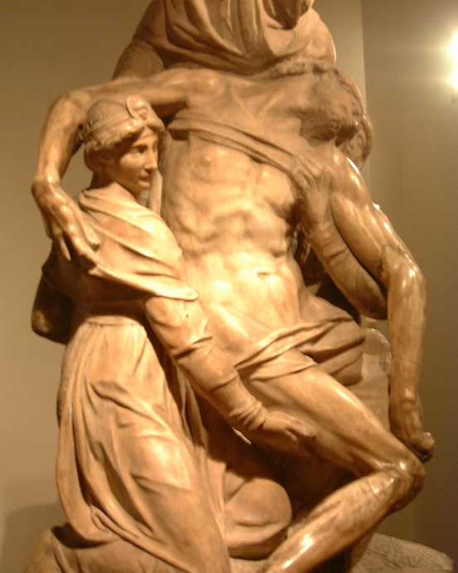
Pietà Bandini (detail) – Michelangelo Buonarroti
Research: how can we take advantage from the use of ICT tools in this field? Among the other we can outline:
- Digital original, as a clone of the artefact to be “used” to some extent instead of the physical original : e.g. Jack Wassermann’s research on the Pietà Bandini, via Appia‘s tombs).
- A number of applications in the field of archaeology including digital terrain mapping and archaeological geographic information systems. Virtual reconstructions and excavations including layered 3D models.
- Reconstruction of the original context and use (frescos, composed paintings, sculptures, objects, mechanisms etc).
- ...
Education / Exploitation; this is very often the “Cinderella” side of memory Institutions. ICT can, if properly used, play a relevant role in boosting this sector. Technology-based cultural heritage services should be used at home, at school and on-site. Indeed, there are many digital cultural data repositories, usually websites that could potentially be linked to form an educational service.
Virtual reconstructions and anastilosis of sites and monuments, re-contextualisation of relicts (e.g. a fragment of an amphora), computer generated movie showing a ceremony or ritual, and more. Digital maps showing selectable layers of the past superimposed onto the actual view. Such an application can be used to offer a complete re contextualisation of scattered objects or to integrate different relicts within their original environment.
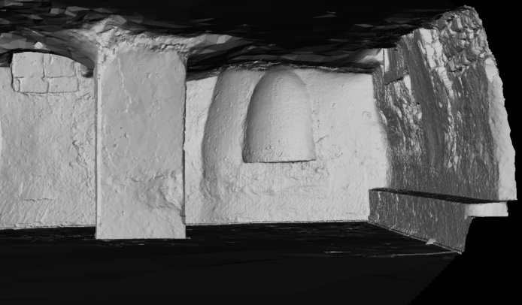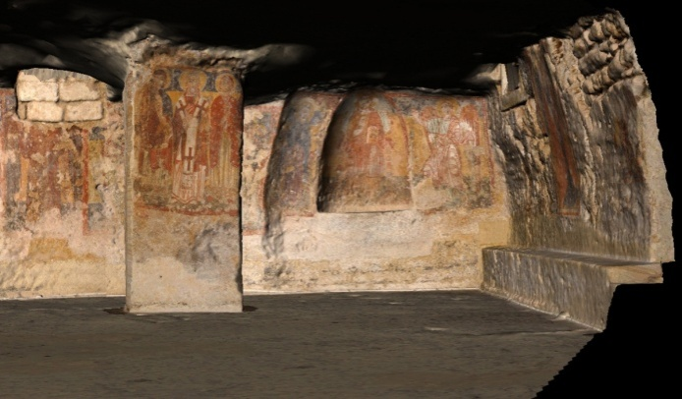
CARPINIANA. A Virtualized Byzantine Crypt by SIBA University of Salento Italy
Some examples are:
- The use of digital originals, virtual reconstructions and digital story telling in order to ease knowledge transfer. The interactive analysis or exploration of a fresco or painting may help in understanding the meaning, the structure, the technique, etc.
- The opportunity to share on line digital images, both “official” and user/visitors generated. User generated content, mainly the visual one, may play a relevant role in opening the broadening the number of artefacts of public interest.
- On and off line interactive catalogues, books and art history courses.
- On line educational resources (e.g. Louvre.edu, etc.).
Artefacts are mainly “communication objects”, so they must communicate with the visitors. ICT has to ease this process by breaking the barriers that sometimes disable the communication process. The communication process associated with cultural heritage involves a reasonable degree of complexity. We can present a work of art and propose an interpretation of it, or try to offer visitors all of the elements required to evaluate the work of art autonomously. Some of the main intrinsic difficulties with the cultural heritage communication process arise from the fact that the work of art usually pertains to a different historical and cultural context from its current situation; indeed, its original location may not be accessible anymore.
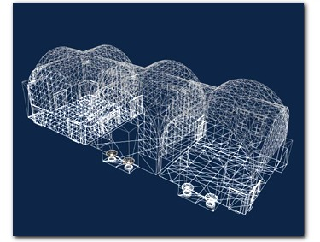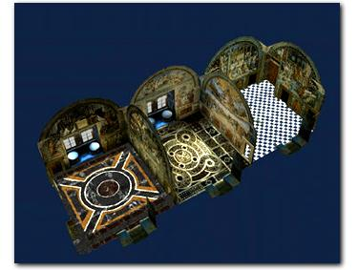
Raffaello’s Rooms by Infobyte Roma Italy (1996)
A relevant added value can be found in the archaeological field. Archaeological sites use to “talk” mainly to experts that are able to “read” clues and hints on the field, archaeological relicts exhibited in museums are mainly “fragments” of objects taken out from their own original physical context.
How many times have we seen descriptions such as “Terracotta Fragment – Second Century”, objects removed from their usual context or function, and artefacts on display without a “code” that can help us to understand their function or meaning? ICT should help to solve such problems, since it should provide context, customised information, references, virtual reconstructions and interactive applications.
One of the main roles of the communications manager must be to rebuild the original context of the work of art in such a way that it is possible to “communicate” it together with all of the elements required to make an objective evaluation. Information science, specifically hypermedia and computer graphics, should offer a fertile field for developing such applications. When rebuilding the typical context of the work of art, another important aspect that is specifically linked to computer graphics and 3-D models is space contextualisation, which means the ability to place the digital 3-D object in the right location while preserving the full set of spatial relations between the model and all of the other objects in the scene.
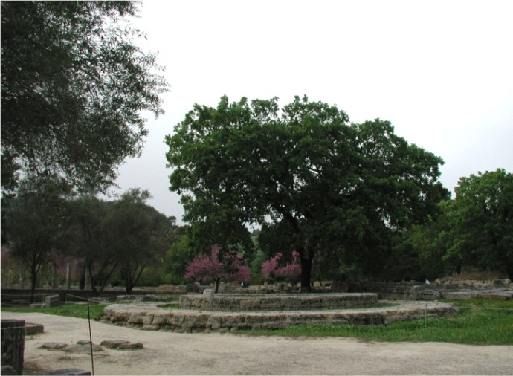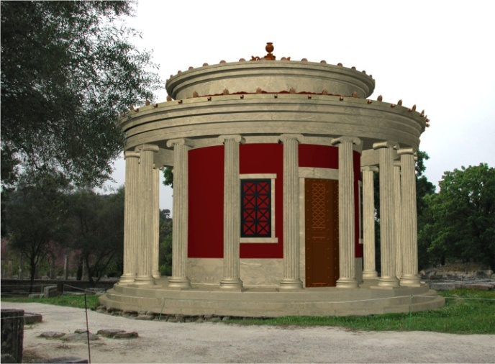
Archeoguide – augmented reality in archaeology by Intracom Greece (2001)
Of course, the implementation of these services will necessitate a different workflow, additional competencies and skills, and more exhibition space in order to host hi-tech installations.
In addition, or as a collateral outcome, “digital originals” may generate additional incomes for memory institutions thanks to:
- Tourism (travel agencies, cultural tourism, etc.).
- Merchandise (museum shops, fashion, gadgets, etc.).
- Advertisement (images, objects, monuments, historical locations, etc.).
- Entertainment ( movie locations, post production, games, etc.).
Last but not leess relevant, in the age of Web X.0, we find user generated content & royalty free content (e.g. museums like Le Louvre, etc or social networks and applications such as Flikr, Google Maps, Panoramio, YouTube, Facebook, etc.). A selected subset of UGC may be canalised and structured in order to create additional cultural services (e.g. “digital cultural content objects” to be picked up to create “touristic trails”).
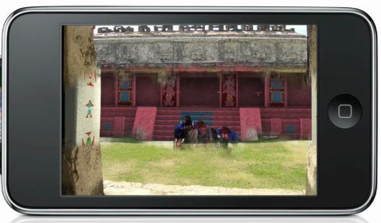
UTOURS – iPod based touristic guide by UTOURS Mexico (http://www.utour.travel/utour/home.html)
Looking at this scenario it seems useful to define some guidelines in order to better take advantage from such investments in time and resources:
It might be useful to draw some guidelines in creating and formatting the copy (layered approach enabling content reuse – international standards for text, visual, audio, audio/visual, etc - e.g. ensuring interoperability and long term preservation...).
It might be useful to define or adopt (e.g. Europeana) a specific ontology in order to properly tag the object and its subparts.
It might be useful to outline a link between the artefact and the set of copies (typology/subject and specific artefact).
Different languages and different cultural models must be adequately taken into account (e.g. multi lingual thesauri).
Create and promote a global repository as a reference point for contributors.

Are digital collections forever?
This paragraph has particular relevance for “memory institutions” such as museums, archives, art galleries, etc. In the last few decades we have witnessed two related processes: the increasingly visible inclusion of electronic devices in our everyday lives, and the rush to digital formats. Institutions, organisations and private companies have recently begun to convert their own archives into digital formats. Moreover the general public has also started to convert personal data into digital formats: documents, music, movies, drawings and photos have been converted from their original formats into bit-streams in digital media.
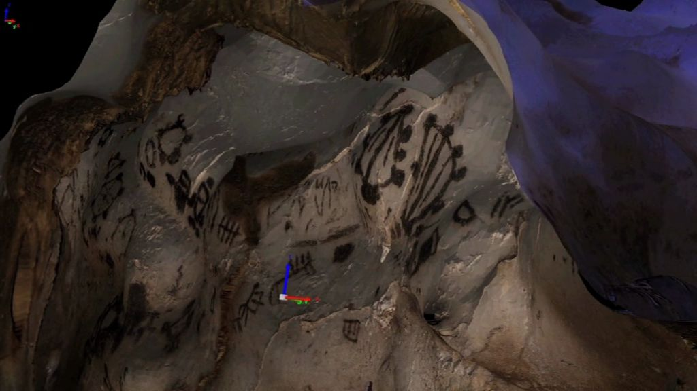
Neolothic Mysteries – revealing in 3D the Grotta dei Cervi of Porto Badisco by SIBA Universrity of Salento, Italy
People used to believe (and many still do) that digital formats were the ultimate formats for storing information indefinitely. The idea that texts, images and more in general data can be perpetuated by converting them into digital form is popular and widely supported.
As a result, a significant amount of our documents and data relies on digital technology. But is digital technology really suitable for long-term preservation? And are electronic devices, which are required in order to access information stored in digital formats, durable enough to guarantee future access to this information? If not, what can we do to overcome this problem?
The rapid evolution of technology makes the preservation of digital content a challenge. Considering the huge amount of data to be stored, the amount of time permitted to accomplish this task, and the length of time that such information needs to be stored, it is important to address the issue of the long-term conservation of digital information a problem that has largely been underestimated up to now even at governmental level.
We need to consider two aspects: technological obsolescence and the temporary nature of “permanent" storage systems. Computer systems are aging; the media on which information is stored are disintegrating. Given this issue, what are the long-term implications of relying on current digital technology to preserve our archives?
Society, of course, has always shown a great deal of interest in preserving materials that document issues, concerns, ideas, creativity, art, discourse and events. Even if we simply focus, for the moment, on basic digital content such as text, we cannot guarantee that textual records stored in digital electronic form will always be accessible.
Although it may seem odd to discuss digital text in this context, there are some important although indirect parallels between the principles described above and those that govern digital text capture.
When capturing “digital text”, it is commonly understood that we do not sample the original in the same way that we sample audio or images. However, the process of text capture does involve making choices about the level of granularity of the resulting digital representation.
When capturing a twentieth-century printed text, for instance, a range of different “data densities” are possible: a simple transcription of the actual letters and spaces printed on the page; a higher-order transcription which also represents the nature of textual units such as paragraphs and headings; or an even more dense transcription which also adds inferential information such as keywords or metrical data.
Other possibilities arise for texts that are structured on different levels of internal granularity. In the case of a mediaeval manuscript, one might create a transcription that captures the graphemes, the individual characters of the text, but does not distinguish between different forms of the same letter (for instance, short and long). Or one might capture these different letter forms, or even distinguish between swashed and unswashed characters. One might also choose to capture variations in spacing between letters, lines of text, and text components, or variations in letter size, or changes in handwriting, or any one of a number of possibly meaningful distinctions.
These distinctions, and the choice of whether or not to capture them, are the equivalent of sampling rates and bit-depth: they govern the amount of information which the digital file records about the analogue source, and the resulting level of nuance that can be obtained when reusing and processing the digital file.
As already outlined, although the loss of data due to the deterioration of storage media is an important consideration, the main issue is that software and hardware technologies rapidly become obsolescent.
Storage media are subject to degradation; they are not designed to survive for long periods of time (the kinds of timescales associated with archives and governmental data). Magnetic technology does not guarantee long-term access to stored information; tapes and disks lose their properties and are sensitive to environmental conditions such as heat, humidity, magnetic fields, static electricity, dust, fire, etc.
In addition, they become obsolete as the devices capable of reading them become outdated and are mothballed. Even though they were once cutting-edge formats, today it is very difficult to obtain equipment that will read a 9600 bpi magnetic tape, a 8” floppy disk or even a 5” ¼ one. The same can be said for early RLL or IDE hard disks. Old formats and standards are essentially shelved in favour of newer formats and standards.
This even happens for software standards, because ways of coding information and the quality of the information stored are constantly improving. This situation holds for both electronic records converted from analogue forms (paper, film, video, sound, etc.), and records that were originally created in electronic form (born digital).
For digital content that is derived from an analogue source, the analogue source (provided it is still available) can be digitised again to new and improved standards and formats, so this issue is not a big problem. On the other hand, content that originated in digital form must be preserved based on the original record.
Until recently, documents were generally paper or microfilm-based. Microfilm technology was popular because of its efficiency, usability, robustness and we now recognise that it is almost hardware-independent. A few decades ago people started to convert microfilm archives into digital archives.
Sometimes the last resort is to keep the data in a safe between one generation and the next. Unfortunately some digital data cannot be converted to paper or microfilm formats. In this case, technology does not help because it is constantly delivering new generations of digital objects that are different to established ones. How can we revert back from a digital signature to paper format, or do so for a cooperative document created on the fly? How can we easily preserve distributed data related to an “inter-governmental” service? How can we permanently store wikis or blogs? Similar concerns are shared by investigators and police organisations interested in preserving “digital evidences” the backbone of “cyber forensics”.
However, today’s data storage methods include digital storage, and more and more organisations are storing more and more of their information digitally. Yet, surprisingly little attention is given to the preservation of digital information over long periods.
The range of digital and electronic assets that need to be preserved spans from high-level and mission-critical information and applications to everyday life objects. This task of preservation will involve highly skilled ad hoc organisations and citizens, the former saving military or census records and the latter saving their photos, music, and documents.

Preservation of Digital Resources: Some Basic Hints
The idea that once you have managed to convert your original into a digital format the hard work is over does not reflect reality; once the digital data have been obtained, it is necessary to consider a different conservation strategy.
One of the first things to consider is that content has its own life cycle. Even though the “paperless” office uses more paper than ever before, and low-cost storage technology has created terabytes of “digital garbage”, we must take into account what is relevant and what it is not; not only because preservation will cost some resources but also because irrelevant data will simply increase the “entropy”.
Another relevant aspect of preservation is related to the data refresh rate to understand fixed information and dynamic information.
The life cycle of the data will influence its own creation and will generate an accounting record for the resources to be preserved. Since prevention is better than cure, if we define preservation strategies we are halfway to the solution. The preservation problem involves several other aspects in addition to the bare technological ones: there are administrative, procedural, organisational, legal, IPR and policy issues surrounding the long-term preservation of digital content. This increased complexity tends to be due to the different natures of digital and traditional physical documents. Online information such as web pages and databases are vulnerable as much as their web structure become complex thanks to hyperlinks and cross references.
At least one aspect should be investigated before settling on a particular preservation approach: the overall cost of preservation. This involves considering the best way to ensure future access to information during the design phase of the long-term data set. This approach may involve some feedbacks on the way to choose technology and standards and even the way to shape data sets. Once the data set is created, in addition to infrastructure costs, running costs may include: additional room on storage devices to archive copies and/or documentation and metadata, software applications that manage data refreshing, and costs related to porting or emulation.
A number of global studies and projects have been and are being carried out into digital preservation; for instance the work carried out by the Taskforce on Archiving of Digital Information (94–96) on the mandate of The Commission on Preservation and Access and The Research Libraries Group Inc., as well as the OASIS Open Archival Information System project, CAMiLEON emulation and the VERS Victorian Electronic Record Strategy. Along with the ERA initiative launched by NARA, Interpares I, II and III are some of the most well known projects in this field. In addition, a comprehensive vision of electronic record management is provided by the US Department of Defence standard entitled the Design Criteria Standard for Electronic Records Management Software Applications (dod 5015.2 STD).
Finally, it is very important that research into digital preservation is carried out by strong interdisciplinary groups, since this should guarantee that an effective approach to a problem that concerns the foundations of the digital era is defined.
Perhaps the only chance of avoiding the “technological quicksand” is to find the “digital Rosetta Stone” in the digital desert.

References
- F. Antinucci (2005) Comunicare nel museo. Editori Laterza, Roma.
- F. Antinucci (2007) Musei virtuali. Come non fare innovazione tecnologica. Editori Laterza, Roma.
- Council of Europe (1999) Digital culture in Europe: A selective inventory of centres of innovation in the arts and new technologies. Council of Europe Publishing, Paris.
- Council of Europe (2001) New information technologies and the young. Council of Europe Publishing, Paris.
- Jeffrey (2001) Council of Europe: Vital links for a knowledge culture. Council of Europe Publishing, Paris.
- H. Lindskog (2001) Time rich time poor. Proc. Global Forum 2001 (see http://www.items. fr).
- R. Makkuni (1998) The Crossings Project. Xerox PARC, Palo Alto, CA (see http://www.sacredworld.org).
- M. McLuhan (1964) Understanding media: The extensions of Man. McGraw-Hill, New York.
- Mulrenin, G. Geser (2002) DigiCULT report: Technological landscapes for tomorrow’s cultural economy: Unlocking the value of cultural heritage. European Commission (Directorate General for the Information Society), Brussels.
- Royal Danish Ministry of Foreign Affairs (2000) The power of culture: The cultural dimension in development. Royal Danish Ministry of Foreign Affairs, Copenhagen, Ch. 3 (see http://www.um.dk/danida/tpoc/index.asp).
- Alfredo M. Ronchi, eCulture: cultural content in the digital age, ISBN 978-3-540-75273-8 e-ISBN 978-3-540-75276-9, DOI 10.1007 / 978-3-540-75276-9, Springer Verlag Berlin Heidelberg 2009.
- L. Thiesmeyer (2002) Indigenous space and cyberspace: Online culture and development in southeast Asia. In: Proc. WWW2002 (Panels), Honolulu, Hawaii, 7–11 May 2002 (see
- http://www.medicif.org or http://www.www2002.org).
- Jacobs et al. (2003) Adaptive grid-based document lay out. ACM Trans. Graph. 22(3).
- Jacobs et al. (2004) Adaptive document layout. Commun. ACM 47(8).
- Infobyte S.p.A.: http://www.infobyte.it/
- Leonardo 3 : www.leonardo3.net

Refer to Alfredo M. Ronchi, eCulture: cultural content in the digital age, ISBN 978-3-540-75273-8 e-ISBN 978-3-540-75276-9, DOI 10.1007 / 978-3-540-75276-9, Springer Verlag Berlin Heidelberg 2009
The term “information superhighway” was popularised by Al Gore (then the US Vice President) in 1994.
See: http://www.medicif.org/Dig_library/ECdocs/reports/Bangemann.html or http://ec.europa.eu/archives/ISPO/infosoc/backg/bangeman.html.
Gottfried Wilhelm Leibniz (also Leibnitz or von Leibniz) was born on July 1, 1646 (Leipzig, Germany), and died on November 14, 1716 (Hanover, Germany). School/tradition: rationalism. Main interests: metaphysics, epistemology, science, mathematics, theodicy. Notable ideas: calculus, innate knowledge, optimism, monad.
The project New Information Technologies and the Young was launched by Screen Digest — General Direction Office IV of the Council of Europe. A final report on the project was published; see Council of Europe (2001).
Of course this is true if the new digitisation process does not create any harm to the original artefact.
Passage from the “Vienna Conclusions” of the conference ICT and Creativity: Towards a Global Cooperation for Quality Content in the Information Society, held in Vienna, Austria, 23 June 2005
http://www.wreckamovie.com/ – “a place where people work together and can build trust among each other so film projects of all types get done and seen.”
E.g. seven scenes http://7scenes.com/, Web 2.0 applications.
Transportation, micro climate and environment, antropic risks, damages due to vandals, etc
Sometimes even forgiving to clearly declare that they are clones. Here starts a different topic: the relevance of the original or the theory of the “fetish”.
Memory Institutions: museums, art galleries, archives, private collections, libraries, etc.
www.leonardo3.net – the Atlantic Codex – Leonardo da Vinci.
E.g. CARPINIANA. A Virtualized Byzantine Crypt - http://sibamframe01.unile.it/carpiniana/carpiniana.asf
Virtual restoration - http://public-repository.epoch-net.org/publications/VAST2005/shortpapers/short2002.pdf
E.g. Methops of Selinunte Temple C – SIBA University of Salento, Italy http://siba3.unile.it/land_lab/metope.htm
http://ieeexplore.ieee.org/Xplore/login.jsp?url=http%3A%2F%2Fieeexplore.ieee.org%2Fiel5%2F5277434%2F5285213%2F05285215.pdf%3Farnumber%3D5285215&authDecision=-203
E.g. http://www.springerlink.com/content/q577468h53p0uu58/
E.g. http://www.research.ibm.com/pieta/pieta_results.htm
http://ieeexplore.ieee.org/Xplore/login.jsp?url=http%3A%2F%2Fieeexplore.ieee.org%2Fiel5%2F7657%2F20918%2F00969659.pdf&authDecision=-203
E.g. EC FP7 CREATE Project http://www.percro.org/index.php?pageId=CREATE
E.g. iPod based “utour” http://www.utour.travel/utour/home.html
http://www.culture.gouv.fr/culture/arcnat/paris/ or http://www.artcom.de/index.php?option=com_acprojects&page=5&id=9&Itemid=113&details=0&imageRequestToggle=0&lang=de&selectedimage=2_pro_museumsinsel/ovr_08_museumsinsel.jpg
In March 2002, the Scrovegni Chapel in Padova was reopened to the public after a long restoration period. In order to better preserve the chapel and particularly Giotto’s frescos in it, a maximum of 25 people were allowed inside at a time for no more than 25 minutes. A group of researchers from CNR ITABC (Roma, Italy)—Maurizio Forte, Claudio Rufa and Eva Pietroni—developed a project entitled Musealising the Virtual: the Virtual Reality Project of the Scrovegni Chapel of Padua 23 that enriches the experience of visiting the chapel. The idea is to boost the learning experiences of visitors by establishing to a “virtuous loop” between computer- assisted briefing and the frescos. Each time one of the two forms of the chapel (i.e. the real and the virtual chapels) is approached, detailed, in-depth information about it is made available.
Sometimes it happens that due to the right to reproduce or the costs related to quality visual documentation and similar reasons, magazines, books and catalogues use to showcase every time the same artefacts.
http://www.louvre.edu/
Artefacts usually come from a different historical period to our own, and so we must re-enable communication between the artefact and the public.
On line support preparing the tour, during the tour (e.g. iPod based) and after the tour (Web 2.0 services).
Many times monuments, sculptures, paintings are relevant part of advertisement messages.
In a long term perspective it can be useful to implement an approach similar to DOI.
As it is for 3D graphics e.g. http://www.the3dstudio.com/
Excerpt from Alfredo M. Ronchi, eCulture: cultural content in the digital age, ISBN 978-3-540-75273-8 e-ISBN 978-3-540-75276-9, DOI 10.1007 / 978-3-540-75276-9, Springer Verlag Berlin Heidelberg 2009.
The time span is mainly related to the national regulations and data/document type (10, 40, 70 years, forever).
National police, Interpol, ENISA, etc.
Next generation cyber forensics – Communications of the ACM February 2006 Volume 49 number 2 and High tech forensics – Communications of the ACM July 2004 Volume 47 number 7.
E.g. The International Expert Meeting “Conservare il digitale”, held in Asolo on 29 September 2006. The report, entitled Long-Term Digital Preservation: An International Focus (see http://www.ndk.cz/dokumenty/asolo_memorandum.pdf/download), was created in order to provide some guidelines and suggestions on this topic.

