Financial Support for Projects in the Field of the Rehabilitation and Transformation of Industrial Buildings into Centers of Modern Culture and a New Type of Art (by Example of the Factories of Imagination: New Territories of Culture Project)
Elena M. Tupyseva
Director, Dance Agency “TsEKH”
The private TsEKH Dance Theaters Agency has been developing Russian contemporary dance since 2000 – a genre of performing art that is new to our country. The comprehensive development of both professional contemporary art and new and experimental forms in Russia does not seem possible without an infrastructure that has been especially-developed and created to include a full suite of the required elements. Important among these are: professional and extended education, the presence of state and private organisations involved in various project activities, and the presence of festivals and – most importantly – new venues for creating and presenting new art forms.
The TsEKH Agency’s creators have spent the past 10 years studying the foreign experience of running new types of venues (cultural centers) that differ in certain parameters from our traditional forms (ones like stationary repertory theatres, cinemas, houses of culture, clubs and so on).
There has been an abundance of examples of innovative cultural spaces being created in Europe over the past 30 to 40 years. Many of these cultural centers (cultural spaces) were set up in buildings of former factories, plants, garages, docks and so on. In September 2006, the TsEKH Agency opened a new venue in Moscow – AKTOVY ZAL (Assembly Hall), which is especially designed for presenting contemporary dance, music and cinema. AKTOVY ZAL is located on the territory of the Oktyabr (October) Non-Printing Paper Plant (Baumanskaya metro station). A part of the plant’s territory has been transformed into the ПROEKT_FABRIKA (Project Factory) creative industries center.
The Factories of Imagination: New Territories of Culture project is a logical continuation of the TSEKH Agency’s 10-year involvement in the study of new centers of culture and art.
The Factories of Imagination: New Territories of Culture is a European-Russian partnership project that was initiated by the TsEKH Dance Theaters Agency (Moscow/Russia) in cooperation with the Trans Europe Halles Network of Independent Cultural Centers, and the following European cultural centers: the Arts Printing House (Latvia), Mains d’Oeuvres (France), Melkweg (the Netherlands), and La Ferme Du Buisson (France). The project was implemented between 2008 and 2009 with support from the European Union, which came within the frameworks of the EU-Russia Partnership Program on Institutional Development: Support for Cultural Cooperation Initiatives, as well as the Ford Foundation.
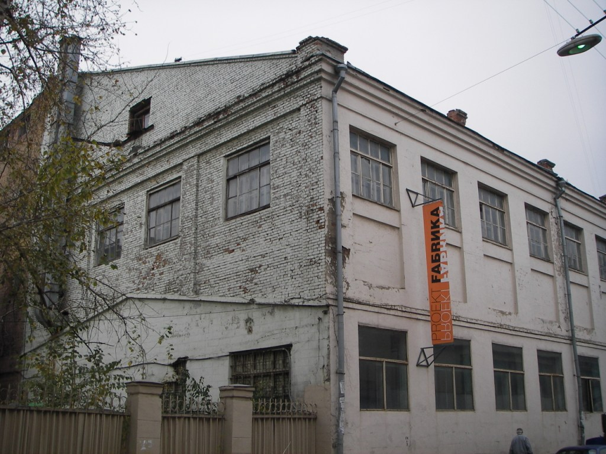
The project was highlighted by a conference entitled the Factories of Imagination: New Territories of Culture / European and Russian Experience of Transforming Industrial Spaces in Centers of Contemporary Culture and Art (October 9-11, 2008). The conference aimed to present the European and Russian experience of transforming industrial space into new centers of contemporary culture and art, thus joining creative professionals of all types in a single space. The conference focused on the following issues: how and why new centers of culture and art appear in cities; what types of spaces are being settled; the main players (representatives of culture, business and the state sector) and their primary functions in reclaiming new spaces; new spaces as an important resource for developing the infrastructure of modern cities.
The conference included a report entitled The Factories of Innovation, or Cultural Conversion: New Cultural Venues in Russia (which was authored by Elena Zelentsova, Nikolai Gladkikh and Ksenya Pushkina). The report analyzed the current state of new cultural spaces’ creation in Russia. Several excerpts from the report are provided below.
.....
The new cultural venues of Moscow are unquestionably tremendously varied, both in terms of their subject matter and types of management. What is characteristic of these venues, and what distinguishes these from similar venues in the West?
The Moscow venues were both created and exist without any state support. Most of the clusters are either wholly or partially the private entrepreneurial initiatives of these venues’ owners. One exception to the case is ПROEKT_FABRIKA, which has enjoyed the recent support of the Ford Foundation. Unlike technology parks, which are scientific centers of innovation that were created and developed with direct state support, innovations in the artistic fields rely exclusively on the support of businessmen and philanthropists. This must make not only the authorities but also the cultural field managers ponder the following question: why have the cultural and creative programs remained on the periphery of state interests? How can one introduce the programs on the creative industries’ development in a manner that is convincing enough for them to find state support?
There is little question that Moscow’s creative venues enjoy a tremendous popularity and demand. Amid Moscow’s total deficit of cultural venues – or simply, a deficit of appropriate venues for creative experiments of any type – almost any new initiative is met with enthusiastic support. Today, ПROEKT_FABRIKA, the Moscow Contemporary Art Center WINZAVOD and the other venues not only do not compete against each other, but on the contrary express a powerful interest in expanding the number of venues that can be used for presenting initiative in the field of contemporary art. The “environment density” of today’s creative venues is much thicker than of their counterpart in Europe and the world.
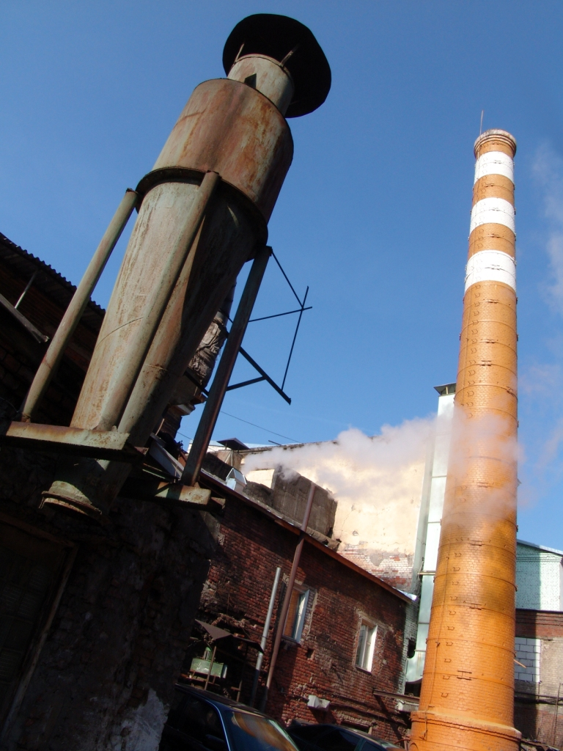
This is precisely why the Moscow venues are distinguished by their involvement in all of the prominent artistic events held in recent years. It is sufficient to recall the Moscow Biannual, which used both the Moscow Contemporary Art Center WINZAVOD and ПROEKT_FABRIKA for its exhibitions.
Фото 2

Moscow’s new cultural venues are primarily composed of contemporary art centers that must simultaneously perform another important mission – to enlighten the public, introducing it to contemporary art. This complete devotion to contemporary art is something that also makes the Moscow venues different from their foreign counterparts.
Moscow’s progress in reclaiming former industrial buildings could not but help being noticed in the regions. As a rule, the regional centers have a lower environmental density and a smaller consumer market than Moscow, which results in their construction of shopping and entertainment centers instead of centers of contemporary art. (For example, this is exactly what happened to the textile factory site in Ivanovo.) However, the absence of any substantial initiatives in the field of contemporary culture and art is more than compensated by tremendous public enthusiasm and gratitude – which is especially evident among the young, who are far less spoiled by the various cultural events available to the Moscow crowd.
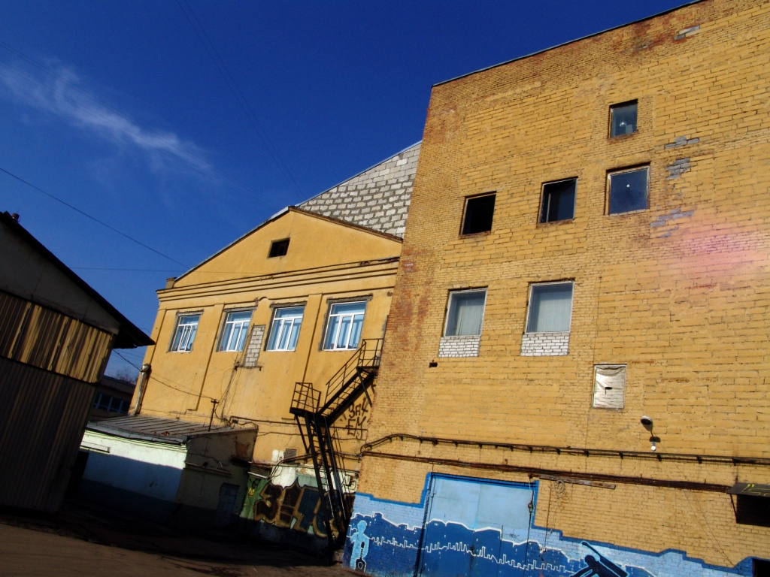
In their attempt to monitor regional initiatives, the authors of this report discovered an entire series of interesting Russian regional projects that are more than likely to soon involve the development of creative clusters and new cultural venues. The greatest activity in this field is currently evident in cities such as Yekaterinburg, Krasnoyarsk Novosibirsk, Perm, Petrozavodsk, Samara and Saint Petersburg.

Thanks to a grant from the European Union, the TSEKH Agency has gained an opportunity to implement a much larger project, attracting cultural organisations from various European nations and Russian cities in its work.
This project resulted in the first attempt to discovered what types of contemporary cultural centers of a new type exist in Russia, establishing professional partnership contacts between this field’s European and Russian colleagues.
The interest expressed by the professional and amateur communities in both the conference and the Factories of Imagination project confirmed this field’s promise in being a part of future cooperation between Russia and the European Union.
Official project site: www.fi.aktzal.ru

